**1. INTRODUCTION**

**1.1 Objectives and scope of the Project**

An effective grievance management system is integral to providing quality customer service. It helps to measure customer satisfaction and is a useful source of information and feedback for improving services. Often customers are the first to identify when things are not working properly.

Implementing effective grievance management systems within public sector agencies:

* Improve internal complaints handling
* Reduces recurring complaints
* Improves standards of service to the community
* Raises standards of administrative decision-making

The following objectives have been set:

1) Smooth flow of data without any hurdles.

2) Adequate validation checks for data entry.

3) Adequate security of data.

4) Facility to update data from time to time.

5) Prompt and specific retrieval of data.

6) Flexibility in the system according to the changing environment.

7) Controlling redundancy in storing the same data multiple times.

8) Accuracy, timeliness and comprehensiveness of the system output.

9) Stability and operability by people of average intelligence.

The **scope** of the system is quite wide. It can be implemented on a WAP-enabled mobile handset, thus providing the Customers and the Providers, the ease of accessing the projects and their status without any difficulty and within no time.

**1.2 Definition of the problem**

To define the problem we have to study the existing system, the problems in the existing system and the needs of the system. After this we will explain the proposed system. Following Points Are defined for the definition of problem:

1. Existing System

2. Needs of the system

3. Proposed system

**1.2.1. Existing System**

One must visit the attorney’s office and make a complaint in the form a written statement and hand it over to him. Plaintiff needs to have the knowledge on what sort of a case it is and who he should be consulting with.

Plaintiff doesn’t get proper attention or response to the case he had put forth. Acknowledgment to his status is achieved only after pursuing the attorney again. Guarantee for the solution of their problems is given through verbal communication only. This requires a lot of time and effort from the client side.

**1.2.2. Need for the System**

The main disadvantage of existing system is book keeping for all the complaints given by the customers. Hence, it is paper consuming task. There is no complaint acknowledgement given for the user, which is used for future references. People don’t get time period for problem recovery.

**1.2.3. Proposed System**

The project we designed can handle the law case details without any difficulty & with a little bit of effort. As the work is done manually before, so it was very time consuming & required a large efforts to maintain the files. By computerizing the system these files can be handled with a small effort & in less time. The chances of duplicity of complaints are negligible. The Customer Case Report can be generated easily by getting the information without any problem from all the related databases. The project is designed by using web technologies; it is very user friendly & easy to use.

The initial investigation has the objectives of determining the validity of the user request for a candidate system & whether a feasibility study should be conducted. The objective of the problem posed by the user must be understood and a solution should be provided.

**1.2.4 Benefits of the Proposed System**

The benefits of the proposed system must also be evaluated. Benefits may be categorized as tangible or intangible.

Tangible benefits that are measured in money terms consist of the saving of

* Time.
* Certain operating costs.

Intangible benefits are more difficult to estimate and justify. They are often impossible to give a money value to. These may include

* Satisfaction of the customers
* Efficiency in handling complaint

**2. REQUIREMENTS SPECIFICATION**

**2.1 Requirement Analysis**

We are overcoming the difficulty of registering the client law cases which were manual in the current system and here we generate detailed information about the complaints which will save our time to inform the attorney who is best suited for the case.

**2.2 Functional Requirements Specification*:***

**Admin:** The administrator logs into the admin page by entering the Username and password. Then any of the following operations can be performed:

View the complaints, Assign them to attorneys, Checking complaint status, View client and attorney details, Add/ Edit new clients and attorneys.

**Client:** Client registration, login, Forgot password, Making complaints, Viewing Status and comments given by attorneys.

**Attorney:** Attorney login, View complaints assigned to him, status updations and adding comments.

**2.3 Non Functional Requirements Specification:**

**Usability**

* This section includes all of those requirements that effect usability.
* We get the response within seconds.
* The software must have a simple, user-friendly interface so clients can save time and confusion. As the project is made using PHP, it has fast loading time than the website made using any other language.

**Reliability**

The system is more reliable because of the qualities that are inherited from the chosen platform PHP. The code built by using PHP is more reliable.

**Supportability**

 The system is designed to be the cross platform supportable. The system is supported on a wide range of hardware and any software platform. This application is being developed using wamp, hence it is extremely portable.

**Implementation**

The system is implemented in web environment. The wamp is used as the web server and windows xp/vista/7 and above is used as the platform.

**Interface**

The user interface is based on the web browser. The application is developed using PHP and HTML. The Interface design is aimed at a flexible front-end communication to provide the user with clear information in navigating a user-friendly interface as planned.

**2.4 Performance Requirements:**

* The completely separate business logic at server side from the client interface ensures good performance.
* The system exhibits high performance because it is well optimized. The business logic is clearly separate from the User Interface.

* The response to the user is within seconds, providing all the information at a glance.

**2.5 Software Requirements:**

* Operating System : 32bit Operating system
* Web Server : WAMP Server
* Web Browser : Internet Explorer
* Front-End : HTML,CSS
* Server side Script : PHP
* Back-End : MySQL

**3. FEASIBILITY STUDY**

A feasibility analysis usually involves a thorough assessment of the operational (need), financial and technical aspects of a proposal. Feasibility study is the test of the system proposal made to identify whether the user needs may be satisfied using the current software and hardware technologies, whether the system will be cost effective from a business point of view and whether it can be developed with the given budgetary constraints. A feasibility study should be relatively cheap and done at the earliest possible time. Depending on the study, the decision is made whether to go head with a more detailed analysis. When a new project is proposed, it normally goes through feasibility assessment. Feasibility study is carried out to determine whether the proposed system is possible to develop with available resources and what should be the cost consideration. Facts considered in the feasibility analysis were

* Technical Feasibility
* Operational Feasibility
* Economic Feasibility

**3.1 Technical Feasibility**

Technical feasibility includes whether the technology is available in the market for development and its availability. The assessment of technical feasibility must be based on an outline design of system requirements in terms of input, output, files, programs and procedures. This can be qualified in terms of volumes of data, trends, frequency of updating, cycles of activity etc, in order to give an introduction of technical system. Considering our project it is technical feasible.

**3.2 Operational Feasibility**

This analysis involves how it will work when it is installed and the assessment of managerial environment in which it is implemented. People are inherently resistant to change and computers have been known to facilitate change. The new proposed system is very much useful to the users and therefore it will accept broad audience from around the world. A proposed system is beneficial only if it can be turned into an information system that will meet the operational requirements of an organization. A system often fails if it does not fit within existing operations and if users resist the change.

Important issues a systems developer must look into are:

* Will the new system be used if implemented in an organization?
* Are there any major barriers to implementation or is proposed system accepted without destructive resistance?

The whole purpose of computerizing the Grievance Management is to handle the work much more accurately and efficiently with less time consumption. There will be additional work to be completed, because now the cellular company will have to maintain database of both their employees as well as their Customers.

Compared to the semi-computerized system the chances of avoiding errors in a computerized system is much higher because the user need not stress himself unnecessarily resulting in recklessness. Unlike the semi-computerized system there would be backup data for all the information concerning the daily transactions occurred within the organization.

Another important fact to be regarded is the security control, which is handled by the system. Since data regarding each Client and the Complaint is confidential, security is a key issue. Information falling into the wrong hands could jeopardize the entire organization. Unlike in semi-computerized systems

The proposed system offers adequate control to protect the organization against fraud and embezzlement and guarantees the accuracy and Security of data and information. This is handled by the system providing individuals with separate login names and passwords.

The new system is user-friendlier, which enables the end-user to complete his/her work efficiently and accurately with interest. After taking the above fact into consideration we can state the operating of the proposed system within the organization is feasible.

In this phase of the feasibility study the following two main topics

1. Technical Performance Aspect and
2. Acceptance within the organization

Technical performance aspect is explained in the technical feasibility report and there is no new information is needed in this to explain it again, but as for the acceptance within the organization the following points are important and those are explained according to the topics.

**Whether the system provides right information to the right place?**

In the current system which is the semi computerized system the information may be lost in the process of sending from one place to another. This is mainly due to human interaction in the process of the transferring information from one place to another.

**Whether the new system affects the current users in the system?**

The new proposed system will affect the users in the following areas

* Accuracy
* Efficiency
* Productivity
* Robustness
* Lesser time consuming

**3.3 Economic Feasibility**

This feasibility study presents tangible and intangible benefits from the project by comparing the development and operational cost. The technique of cost benefit analysis is often used as a basis for assessing economic feasibility. This system needs some more initial investment than the existing system, but it can be justifiable that it will improve quality of service. Thus feasibility study should center along the following points:

* Improvement resulting over the existing method in terms of accuracy, timeliness.

* Cost comparison

* Estimate on the life expectancy of the hardware.

**Overall objective:**

Our project is economically feasible. It does not require much cost to be involved in the overall process. The overall objective is in easing out the complaints management process.

**4. SYSTEM ANALYSIS AND DESIGN**

**4.1 System Analysis Introduction**

System analysis is the process of studying the business processors and procedures, generally referred to as business systems, to see how they can operate and whether improvement is needed. This may involve examining data movement and storage, machines and technology used in the system, programs that control the machines, people providing inputs, doing the processing and receiving the outputs.

The proposed model which is developed does not only depend on the system’s working process, but also it depends on the working of the flow of the process which needs to be considered. The proposed model acts as the platform for the users to address the problem regarding any issue and which should be handled carefully. The proposed model introduces a new user called privileged user, who has the right on the entire system, the process work flow of the privileged user is shown in the representation given below. The privileged user has access with both admin level and customer side. He can be able to view the tasks, requests, complaints, login details of both the user and admin. The privileged user has to login into the system first, and then access the data as he wants. Privileged user can be able to view the complaints reported by the user and also the managed complaints by admin. In the managed complaints, he will check for the solved and unsolved complaints. If there are any unsolved complaints, he will take actions towards the problem.

**4.2 System Design**

This grievance handling system is mainly developed to provide the user the process of making a complaint easy, it also made the process of registering a complaint through online. The different types of law complaints made by different users are made integrated in a web portal. The admin of the portal manages all the complaints and passes those complaints to the respective complaint handling departments. By this process, the users are made satisfied regarding their problems. This project makes extension to the already existed process by integrating all type of complaints together and provides solutions for those problems within the convenient time and without any effort.

**INPUT DESIGN:**

The input design is the link between the information system and the user. It comprises the developing specification and procedures for data preparation and those steps are necessary to put transaction data in to a usable form for processing can be achieved by inspecting the computer to read data from a written or printed document or it can occur by having people keying the data directly into the system. The design of input focuses on controlling the amount of input required, controlling the errors, avoiding delay, avoiding extra steps and keeping the process simple. The input is designed in such a way so that it provides security and ease of use with retaining the privacy. Input Design considered the following things:

* What data should be given as input?
* How the data should be arranged or coded?
* The dialog to guide the operating personnel in providing input.
* Methods for preparing input validations and steps to follow when error occur.

**OBJECTIVES:**

1. Input Design is the process of converting a user-oriented description of the input into a computer-based system. This design is important to avoid errors in the data input process and show the correct direction to the management for getting correct information from the computerized system.

2. It is achieved by creating user-friendly screens for the data entry to handle large volume of data. The goal of designing input is to make data entry easier and to be free from errors. The data entry screen is designed in such a way that all the data manipulates can be performed. It also provides record viewing facilities.

3. When the data is entered it will check for its validity. Data can be entered with the help of screens. Appropriate messages are provided as when needed so that the user will not be in maize of instant. Thus the objective of input design is to create an input layout that is easy to follow.

**OUTPUT DESIGN:**

A quality output is one, which meets the requirements of the end user and presents the information clearly. In any system results of processing are communicated to the users and to other system through outputs. In output design it is determined how the information is to be displaced for immediate need and also the hard copy output. It is the most important and direct source information to the user. Efficient and intelligent output design improves the system’s relationship to help user decision-making.

1. Designing computer output should proceed in an organized, well thought out manner; the right output must be developed while ensuring that each output element is designed so that people will find the system can use easily and effectively. When analysis design computer output, they should Identify the specific output that is needed to meet the requirements.

2. Select methods for presenting information.

3. Create document, report, or other formats that contain information produced by the system.

The output form of an information system should accomplish one or more of the following objectives.

* Convey information about past activities, current status or projections of the
* Future.
* Notify important events, opportunities, problems, or warnings.
* Trigger an action.
* Confirm an action.

**4.3 Tier Concept**

The four tiers describe the separation of functionality into layers with each segment being a tier that can be located on a physically separate computer. It can be used in web applications and distributed applications. The strength in particular is when using this architecture over distributed systems. The proposed model is categorized into 4-layers that consist of the following.

Database layer: The database tier contains data about different user’s information and their details, Attorney’s information, list of problems pertaining to different law cases and shared people profiles.

Data Access layer: It is the intermediate layer which communicates with the database.

Business logic tier: It consists of the admin information of the system i. e, complaint handling and acknowledgement components.

Presentation tier: It consists of web-based user interface.



Fig. 4.3 Tier Concept

**4.4 Implementation Design**

After the workflow process and the proposed systems have been described, the implementation model takes place which is given as follows.

Compared with the other diagrams, component diagrams are different in their nature. These diagrams are mainly used to model the physical aspects like executables, files, documents, etc. of any system. The component diagram of this system visualizes the components of the system and also explains the relationship between the components. As the complaints, clients and attorneys vary in their responsibilities, then basing on their roles, the system mainly deals with three types of roles which are user, admin, client and attorney.



Fig. 4.4 User Roles

**4.5 DESIGN DIAGRAMS**

**4.5.1 DATA FLOW DIAGRAM**

A data flow diagram is graphical tool used to describe and analyze movement of data through a system. These are the central tool and the basis from which the other components are developed. The transformation of data from input to output, through processed, may be described logically and independently of physical components associated with the system. These are known as the logical data flow diagrams. The physical data flow diagrams show the actual implements and movement of data between people, departments and workstations. A full description of a system actually consists of a set of data flow diagrams. Each component in a DFD is labeled with a descriptive name. Process is further identified with a number that will be used for identification purpose. The development of DFD’S is done in several levels. Each process in lower level diagrams can be broken down into a more detailed DFD in the next level. The lop-level diagram is often called context diagram. It consists of a single process bit, which plays vital role in studying the current system. The process in the context level diagram is exploded into other process at the first level DFD.

This is done until further explosion is necessary and an adequate amount of detail is described for analyst to understand the process. Larry Constantine first developed the DFD as a way of expressing system requirements in a graphical from, this lead to the modular design. A DFD is also known as a “bubble Chart” has the purpose of clarifying system requirements and identifying major transformations that will become programs in system design. So it is the starting point of the design to the lowest level of detail. A DFD consists of a series of activities joined by data flows in the system.

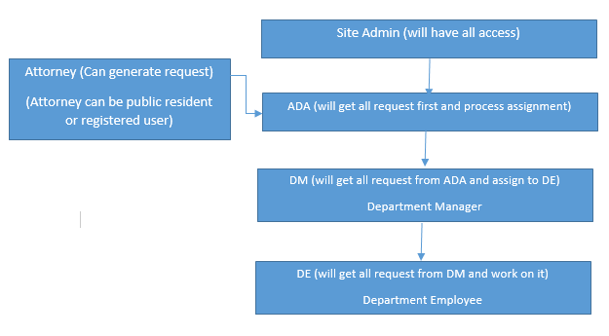

Complaint forwarding

**Figure: 4.5.1 Data Flow Diagram**

**4.5.2 UML Diagrams**

UML stands for Unified Modeling Language developed by Grady Booch, James Rumbaugh, and Ivar Jacobson of Rational Corporation in 1996. It is a standard, modeling language used for modeling software systems of varying complexities. It is used to understand design, configure, maintain and control information about systems.

UML is a notation that resulted from the unification of OMT and OOSE. Diagrams are used to represent multiple views of a system. The multiple views of the system together represent the model of the system.

**4.5.2.1 Use case diagrams**:

Use case diagrams are used during requirements elicitation and analysis to represent the functionality of the system. Use cases focus on the behaviour of the system from an external point of view.

** Fig. 4.5.2.1: Use case Diagram**

**4.5.2.2 CLASS DIAGRAM**

Class diagrams are used to describe the structure of system. Classes are abstractions that specify the common structure and behaviour of a set of objects. Objects are the instances of classes.



**Fig. 4.5.2.2: Class Diagram**

The class diagram shows all the components of the entire system and how they are interfaced with each other.

**4.5.2.3 Sequence Diagrams**

Sequence diagram document the interactions between classes to achieve a result, such as a use case. Because UML is designed for object-oriented programming, these communications between classes are known as messages. The Sequence diagram lists objects horizontally, and time vertically, and models these messages over time.

 **Fig.4.5.2.3: Sequence Diagram**

**4.5.2.4 Activity Diagram:**

Activity diagrams are graphical representations of workflows of stepwise activities and actions with support for choice, iteration and concurrency. In the Unified Modeling Language, an activity diagram shows the overall flow of control.

 **Fig. 4.5.2.4 Activity Diagram**

**5. SYSTEM IMPLEMENTATION**

Implementation is the stage in the project where the theoretical design is turned into the working system and is giving confidence to the new system for the users i.e. will work efficiently and effectively. It involves careful planning, investigation of the current system and its constraints on implementation, design of method to achieve the changeover, an evaluation, of changeover methods. A part from planning major task of preparing the implementation is education of users. The more complex system is implemented, the more involved will be the system analysis and design effort required just for implementation. An implementation coordinating committee based on policies of individual organization has been appointed. The implementation process begins with preparing a plan for the implementation for the system. According to this plan, the activities are to be carried out, discussions may regarding the equipment has to be acquired to implement the new system.

Implementation is the final and important phase. The most critical stage is in achieving a successful new system and in giving the users confidence that the new system will work and be effective. The system can be implemented only after thorough testing is done and if it found to working according to the specification. This method also offers the greatest security since the old system can take over if the errors are found or inability to handle certain types of transaction while using the new system.

**5.1 DEVELOPMENT TOOLS**

**5.1.1 HTML:**

The Hyper Text Markup language (HTML) is a simple markup language used to create hypertext documents that are portable from one platform to another. HTML documents are SGML documents with generic semantics that are appropriate for representing information from a wide range of applications. This specifications defines HTML version 4.0 HTML 4.0 aims to capture recommended practice as of early ’96 and as such to be used as a replacement for HTML 3.2

**Why to use HTML*:***

Web site is a collection of pages, publications and documentation that resides on web server. While these page publication and a document as a formatted in any single format you should use HTML for home page and all primary pages and the site. This will enable the millions of web users it considered first formatting any new material you plan to publish on the web HTML documents are platform independent, meaning that they don’t conform to any standard it they are created properly you can more home page to any server platform or you can access them with any complaint www browser.

**5.1.2 PHP:**

PHP is a general-purpose scripting language that is especially suited to server-side web development where PHP generally runs on a web server. Any PHP code in a requested file is executed by the PHP runtime, usually to create dynamic webpage content or dynamic images used on Web sites or elsewhere. It can also be used for command-line scripting and client-side graphical user interface (GUI) applications. PHP can be deployed on most Web servers, many operating systems and platforms, and can be used with many relational database management systems (RDBMS). It is available free of charge, and the PHP Group provides the complete source code for users to build, customize and extend for their own use.

PHP acts primarily as a filter, taking input from a file or stream containing text and/or PHP instructions and outputting another stream of data; most commonly the output will be HTML. Since PHP 4, the PHP parser compiles input to produce bytecode for processing by the Z-end Engine, giving improved performance over its interpreter predecessor.

Originally designed to create dynamic Web pages, PHP now focuses mainly on server-side scripting, and it is similar to other server-side scripting languages that provide dynamic content from a Web server to a client, such as Microsoft's ASP.NET, Sun Microsystems 'JavaServer Pages, and mod perl.

**Speed optimization:**

PHP source code is compiled on-the-fly to an internal format that can be executed by the PHP engine. In order to speed up execution time and not have to compile the PHP source code every time the Web page is accessed, PHP scripts can also be deployed in executable format using a PHP compiler. Code optimizers aim to enhance the performance of the compiled code by reducing its size, merging redundant instructions and making other changes that can reduce the execution time. With PHP, there are often opportunities for code optimization. An example of a code optimizer is the Accelerator PHP extension. Another approach for reducing compilation overhead for PHP servers is using an opcode cache. Opcode caches work by caching the compiled form of a PHP script (opcodes) in shared memory to avoid the overhead of parsing and compiling the code every time the script runs. An opcode cache, APC, is planned to be built into an upcoming release of PHP. Opcode caching and code optimization can be combined for best efficiency, as the modifications do not depend on each other (they happen in distinct stages of the compilation).

**5.1.3 MYSQL:**

MySQL, the most popular Open Source SQL database management system, is developed, distributed, and supported by Oracle Corporation.

* **MySQL is a database management system*.***

A database is a structured collection of data. It may be anything from a simple shopping list to a picture gallery or the vast amounts of information in a corporate network. To add, access, and process data stored in a computer database, you need a database management system such as MySQL Server. Since computers are very good at handling large amounts of data, database management systems play a central role in computing, as standalone utilities, or as parts of other applications.

* **MySQL databases are relational.**

A relational database stores data in separate tables rather than putting all the data in one big storeroom. The database structures are organized into physical files optimized for speed. The logical model, with objects such as databases, tables, views, rows, and columns, offers a flexible programming environment. You set up rules governing the relationships between different data fields, such as one-to-one, one-to-many, unique, required or optional, and “pointers” between different tables. The database enforces these rules, so that with a well-designed database, your application never sees inconsistent, duplicate, orphan, out-of-date, or missing data. The SQL part of “MySQL” stands for “Structured Query Language”. SQL is the most common standardized language used to access databases. Depending on your programming environment, you might enter SQL directly (for example, to generate reports), embed SQL statements into code written in another language, or use a language-specific API that hides the SQL syntax.

* **MySQL software is Open Source.**

Open Source means that it is possible for anyone to use and modify the software. Anybody can download the MySQL software from the Internet and use it without paying anything. If you wish, you may study the source code and change it to suit your needs. The MySQL software uses the GPL (GNU General Public License).

* **The MySQL Database Server is very fast, reliable, scalable, and easy to use.**
* **MySQL Server works in client/server or embedded systems.**

The MySQL Database Software is a client/server system that consists of a multi-threaded SQL server that supports different backends, several different client programs and libraries, administrative tools, and a wide range of application programming interfaces (APIs).

* **A large amount of contributed MySQL software is available.**

MySQL Server has a practical set of features developed in close cooperation with our users. It is very likely that your favorite application or language supports the MySQL Database Server. A web server is required for the execution of PHP scripts. Hosting can be done in two ways, either by buying a domain and using it or by using software for local hosting.

**5.1.4 WAMP SERVER:**

**WAMP** is a free and open source cross-platform web server solution stack package created by Romain Bourdon, consisting mainly of the Apache HTTP Server, MySQL database, and interpreters for scripts written in the PHP programming language. WAMP's name is an acronym for:

 Windows Apache HTTP Server MySQL PHP

**5.2 MODULES:**

**CLIENT MODULE –**

The client can create a login with all his personal information given during the registration time, and can view the different categories of law cases and the available attorneys for each, thereby making a complaint and also selecting their preferred attorney, later view the complaint details and track the status of the case. The client can also see the comments given by the working attorney time – to - time.

The various php pages responsible for this client module are register.php, main.php, process.php, viewCompbyId.php etc.

HOME- It gives the basic information about the online grievance system.

MAKE COMPLAIN- It allows the client to give the complaint details by knowing about different types of law cases and select the preferred attorney for the case.

VIEW COMPLAIN DETAILS- The client can view the complaint details, status and the comment posted by the attorney.

LOG OUT- logs out from the client module and returns to the login page.

**ADMIN MODULE –**

Admin has the permissions to access and view the complaints and provide or assign them to a suitable attorney or a preferred attorney on a specified request. The admin has the rights to edit or delete the clients and attorneys details.

ASSIGN COMPLAINS- Assigns the complaints for attorneys.

VIEW COMPLAIN DETAILS- views the details and status of the case.

VIEW CLOSE COMPLAINS- views the complaints that got closed by the attorneys.

ATTORNEYS DETAILS- views the attorneys details and can add new attorneys by giving them new username and password.

CLIENTS DETAILS- views the clients details those have registered their complaints.

REPORTS- In this tab the admin can view different pages reports based on their status along with clients and attorneys details.

LOG OUT - logs out from the admin module and returns to the login page.

**ATTORNEY MODULE-**

Attorney logins to the system with the username and password given by the admin and views the complaints assigned to him. Then he can perform the action and can post his comments on the case.

VIEW COMPLAINS- Attorney can view the complaint details that are assigned to him and update their status to working.

CLOSE COMPLAINS- In this tab he can close the particular complaint.

LOGOUT- logs out from the attorney module by returning to the login page.

**5.3 DATABASE DESIGN**

A database is a collection of interrelated data stored with the minimum redundancy to serve many users quickly and efficiently. The general objective is to make information access quick, in expensive and flexible for the user. The tables are organized

* To reduce data duplication and hence inconsistency.
* To enable the efficient storage and retrieval.

**TABLES**

|  |  |  |
| --- | --- | --- |
| **Name** | **Data Type** | **Description** |
| CID(PRIMARY KEY) | INTEGER | Complaint ID |
| CUST_ID | INTEGER | Customer ID |
| CUST_NAME | VARCHAR | Customer Name |
| COMP_TYPE | VARCHAR | Type of Complaint |
| COMP_TITLE | VARCHAR | Complaint Title |
| COMP_DESC | TEXT | Complaint description |
| STATUS | VARCHAR | Status of Complaint |
| ENG_ID | INTEGER | Attorney ID |
| ENG_NAME | VARCHAR | Attorney Name |
| ENG_COMMENT | VARCHAR | Comments given by Attorney |
| CREATE_DATE | DATETIME | Creation of Complaint date |
| CLOSE_DATE | DATETIME | Close date of the Complaint |
| ATTORNEY_NAME | VARCHAR | Preferred attorney by client |

* + 1. **Complaints table**

|  |  |  |
| --- | --- | --- |
| **Name** | **Data Type** | **Description** |
| EID(PRIMARY KEY) | INTEGER | Attorney ID |
| ENAME | VARCHAR | Attorney Name |
| EPASS | VARCHAR | Password of the Attorney |
| ADDRESS | VARCHAR | Address of the Attorney |
| EMAIL | VARCHAR | E-mail ID |
| E_MOBLIE | VARCHAR | Mobile number |
| DATE_TIME | DATETIME | Time of registration |

* + 1. **Attorneys table**

**5.3.3 Clients table**

|  |  |  |
| --- | --- | --- |
| **Name** | **Data Type** | **Description** |
| CID | INTEGER | Client ID |
| CNAME | VARCHAR | Client Name |
| CPASS | VARCHAR | Password of the Client |
| ADDRESS | VARCHAR | Address of the Client |
| EMAIL | VARCHAR | Email of the client |
| C_MOBILE | VARCHAR | Mobile Number |
| DATE_TIME | DATETIME | Time of registration |

**5.4 CODING**

**login.php**

<?php

require_once './library/config.php';

require_once './library/functions.php';

$errorMessage = '&nbsp;';

if (isset($_POST['txtUserName'])) {

$result = doLogin();

if ($result != '') {

$errorMessage = $result;

}

}

?>

<html>

<head>

<title>Grievance Management System- Login</title>

<meta http-equiv="Content-Type" content="text/html; charset=iso-8859-1">

<link href="include/admin.css" rel="stylesheet" type="text/css">

<link href="<?php echo WEB_ROOT;?>include/style.css" rel="stylesheet" type="text/css">

<link href="<?php echo WEB_ROOT;?>include/main.css" rel="stylesheet" type="text/css">

</head>

<body>

<br/>

<br/>

<table width="900" border="0" align="center" cellpadding="0" cellspacing="1" class="graybox">

<tr>

<td><img src="images/complains.jpg" width="900" height="120"></td>

</tr>

<tr>

<td valign="top"> <table width="100%" border="0" cellspacing="0" cellpadding="20">

<tr>

<td class="contentArea"> <form method="post" name="frmLogin" id="frmLogin">

<p>&nbsp;</p>

<table width="350" border="0" align="center" cellpadding="5" cellspacing="1" bgcolor="#336699" class="entryTable">

<tr id="entryTableHeader">

<td>:: User Login ::</td>

</tr>

<tr>

<td class="contentArea">

<div class="errorMessage" align="center"><?php echo $errorMessage; ?></div>

<table width="100%" border="0" cellpadding="2" cellspacing="1" class="text">

<tr align="center">

<td colspan="3">&nbsp;</td>

</tr>

<tr class="text">

<td width="100" align="right">User Name</td>

<td width="10" align="center">:</td>

<td><input name="txtUserName" type="text" class="box" id="txtUserName" size="30" maxlength="40"></td>

</tr>

<tr>

<td align="right">Password</td>

<td align="center">:</td>

<td><input name="txtPassword" type="password" class="box" id="txtPassword" size="30" maxlength="40"></td>

</tr>

<tr>

<td width="100" align="right">User Type </td>

<td width="10" align="center">:</td>

<td><label>

<select name="utype" class="box">

<option >&nbsp;&nbsp;--- Select User --- &nbsp;</option>

<option value="admin">&nbsp;&nbsp; Administrator &nbsp;</option>

<option value="customer">&nbsp;&nbsp; Client &nbsp;</option>

<option value="employee">&nbsp;&nbsp; Attorney &nbsp;</option>

</select>

</label></td>

</tr>

<tr>

<td colspan="2">&nbsp;</td>

<td>&nbsp;</td>

</tr>

<tr>

<td colspan="2">&nbsp;</td>

<td><div align="right">New Client? <a href="register.php">Register Here</a> </div></td>

</tr>

<tr>

<td colspan="3"><div align="right"><a href="forget-password.php">Forget Password</a> </div></td>

</tr>

<tr>

<td colspan="2">&nbsp;</td>

<td><input name="btnLogin" type="submit" id="btnLogin" value=" Login Now " style="font-size:14px;color:#0066FF;padding:5px 8px;"></td>

</tr>

</table></td>

</tr>

</table>

<p>&nbsp;</p>

</form></td>

</tr>

</table></td>

</tr>

</table>

</body>

</html>

**6. SYSTEM TESTING**

Testing is the process of detecting errors. Testing performs a very critical role for quality assurance and for ensuring the reliability of software. The results of testing are used later on during maintenance also.

**Testing Objectives include:**

The main objective of testing is to uncover a host of errors, systematically and with minimum effort and time. Stating formally, we can say,

1. Testing is a process of executing a program with the intent of finding an error
2. A good test case is one that has a probability of finding an as yet undiscovered error
3. A successful test is one that uncovers an undiscovered error

**Testing Principles:**

* All tests should be traceable to end user requirements
* Tests should be planned long before testing begins
* Testing should begin on a small scale and progress towards testing in large
* Exhaustive testing is not possible
* To be most effective testing should be conducted by an independent third party.

It is the process of exercising software with the intent of ensuring that the software system meets its requirements and user expectations and does not fail in an unacceptable manner. There are various types of test. Each test type addresses a specific testing requirement.

**TESTING STRATEGIES**

A Strategy for software testing integrates software test cases into a series of well planned steps that result in the successful construction of software. Software testing is a broader topic for what is referred to as Verification and Validation. Verification refers to the set of activities that ensure that the software correctly implements a specific function. Validation refers the set of activities that ensure that the software that has been built is traceable to customer’s requirements.

**Unit Testing:**

Unit testing focuses verification effort on the smallest unit of software design that is the module. Using procedural design description as a guide, important control paths are tested to uncover errors within the boundaries of the module. The unit test is normally white box testing oriented and the step can be conducted in parallel for multiple modules.

**White Box Testing:**

This is a unit testing method where a unit will be taken at a time and tested thoroughly at a statement level to find the maximum possible errors. The white box testing is also called Glass Box Testing. This testing is done step wise where every piece of code is tested, taking care that every statement in the code is executed at least once.

**Black Box Testing:**

This testing method considers a module as a single unit and checks the unit at interface and communication with other modules rather getting into details at statement level. Here the module will be treated as a black box that will take some input and generate output. Output for a given set of input combinations are forwarded to other modules.

**Integration Testing:**

Integration testing is a systematic technique for constructing the program structure, while conducting test to uncover errors associated with the interface. The objective is to take unit tested methods and build a program structure that has been dictated by design.

**Validation Testing:**

At the end of integration testing software is completely assembled as a package. Validation testing is the next stage, which can be defined as successful when the software functions in the manner reasonably expected by the customer. Reasonable expectations are those defined in the software requirements specifications.

**System Testing:**

System testing is actually a series of different tests whose primary purpose is to fully exercise the computer-based system. Although each test has a different purpose, all work to verify that all system elements have been properly integrated to perform allocated functions.

**Performance Testing:**

This method is designed to test runtime performance of software within the context of an integrated system.

|  |  |  |  |  |
| --- | --- | --- | --- | --- |
| **Test id** | **Check item** | **Objective** | **Steps to Execute** | **Expected Result** |
| 1 | Username | Leave the username field blank and click login button | Click login | By leaving the username blank and click login it will display error message |
| 2 | Password | Leave password field blank and click register button | Click login | It will display error message as “Enter password” |
| 3 | User Type | Select wrong user type | Click login | It shows an error message as  “login using another role” |
| 4 | Address | Leave this field as blank | Click Register | It shows an error message as  “must enter address” |
| 5 | Mobile | Leave this field as blank | Click Register | It shows an error message as  “must enter mobile number” |
| 6 | Mobile | Enter less than 10 digits | Click Register | It shows an error message as  “mobile number must contain 10 digits” |
| 7 | Email | Leave this field as blank | Click Register | It shows an error message as “Must enter email” |

**Table. No. 6.1. Test Cases**

**Screenshots for Test Cases:**

**Test id 1:** By leaving the username blank and click login it will display error message

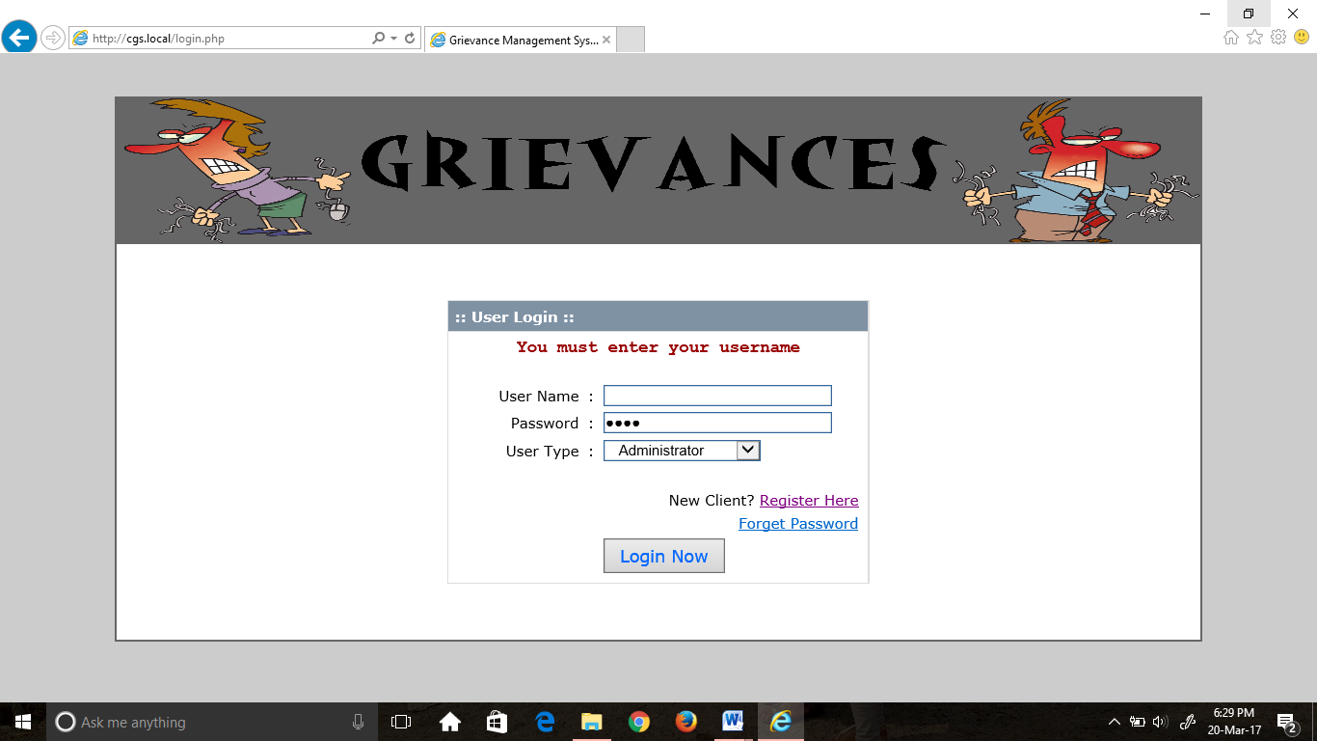

**Screenshot. No. : 6.1. Invalid Username**

**Test id 2:** Leave password field blank and click login button displays an error message.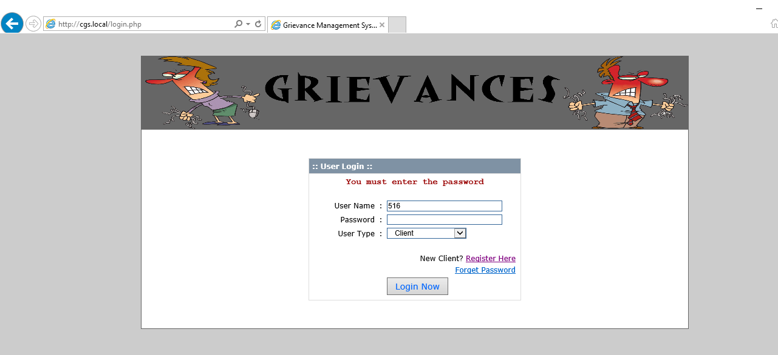

**Screenshot. No. :6.2: Invalid Password**

**Test id 3:** By selecting wrong user type, it shows an error message as

“login using another role”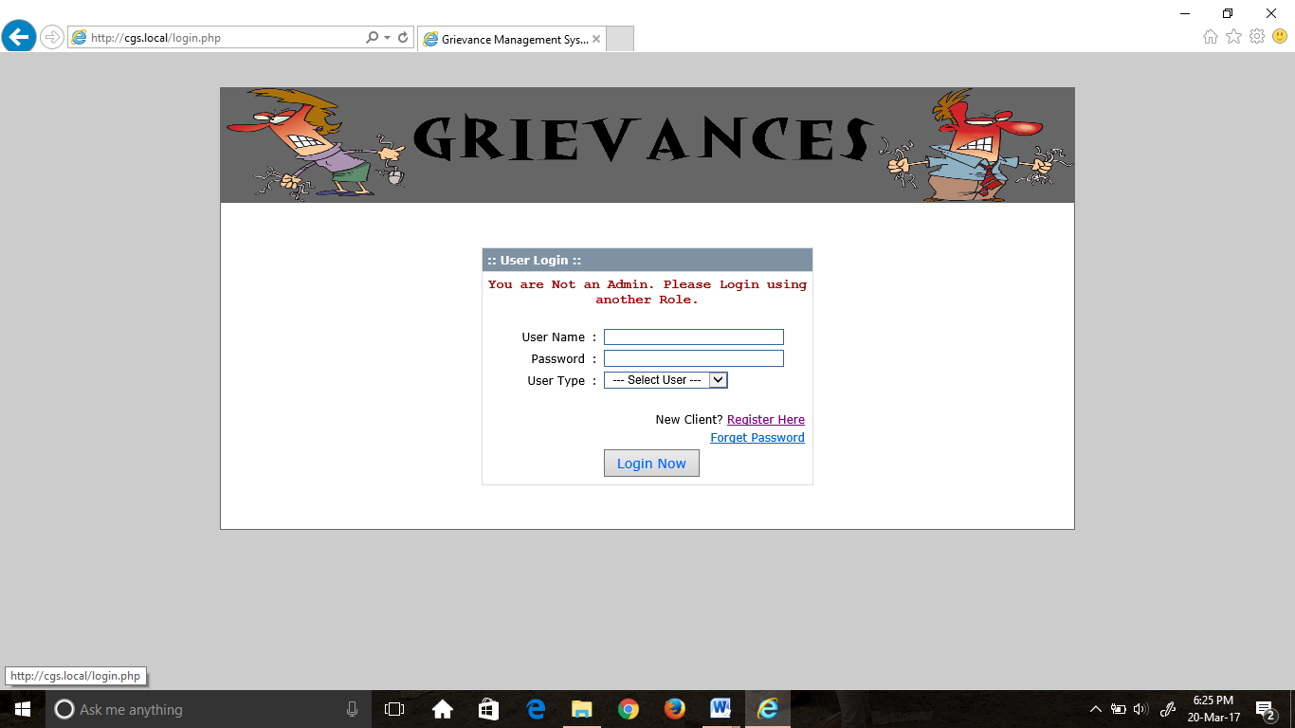

**Screenshot. No. :6.3: Invalid Usertype**

**Test id 4:** By leaving the address field as blank it shows an error message as

“must enter address”

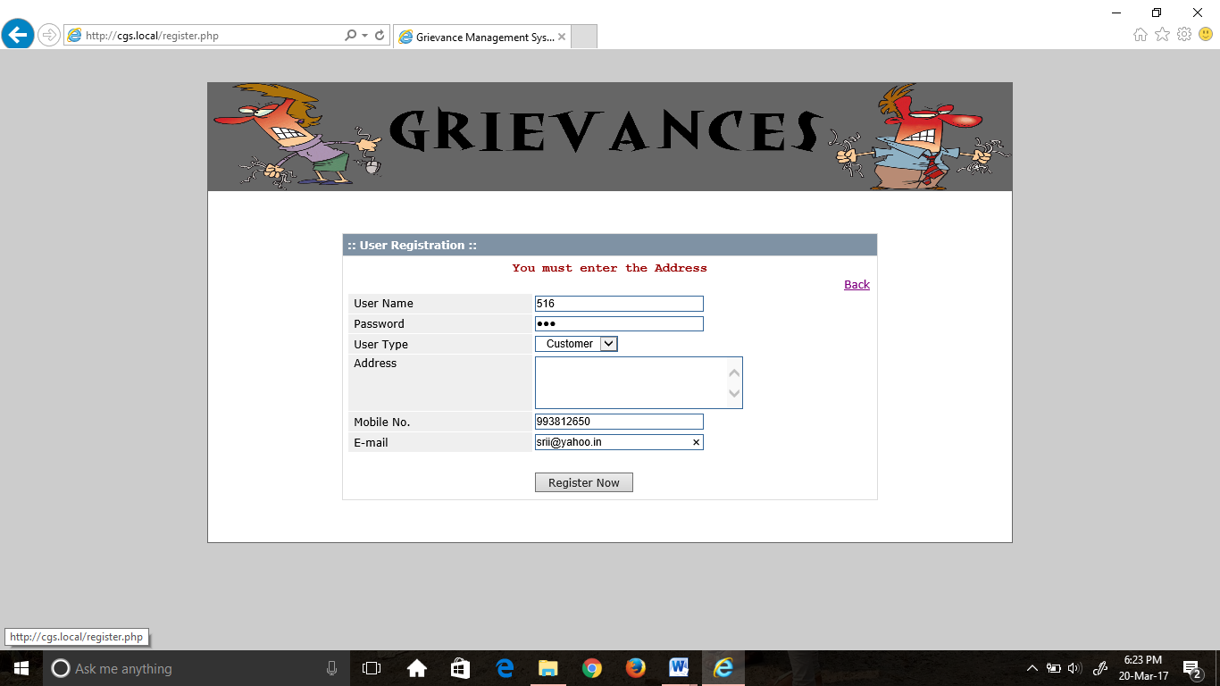

**Screenshot. No: 6.4: Leaving Address Field Empty**

**Test id 5:** By leaving the mobile No. field empty it shows an error message as

“must enter mobile number”

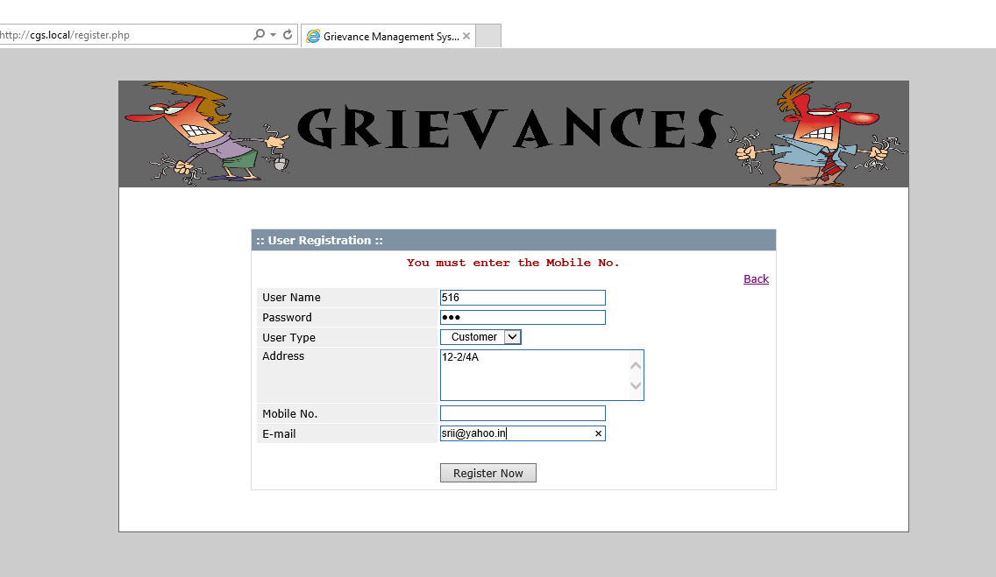 **Screenshot. No: 6.5: Leaving Mobile No. Field Empty**

**Test id 6:** By entering less than 10 digits in mobile number it displays an errror.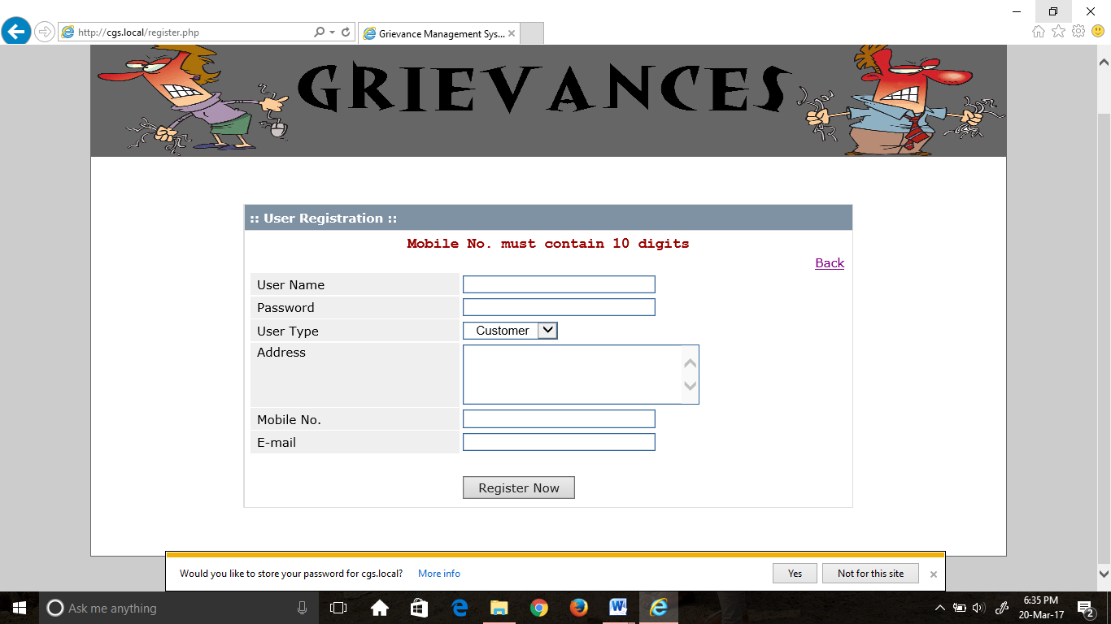

**Screenshot. No: 6.6: Invalid Mobile Number**

**Test id 7:** Leaving Email id filed empty in registration form will display an error message as “Enter the email ”.

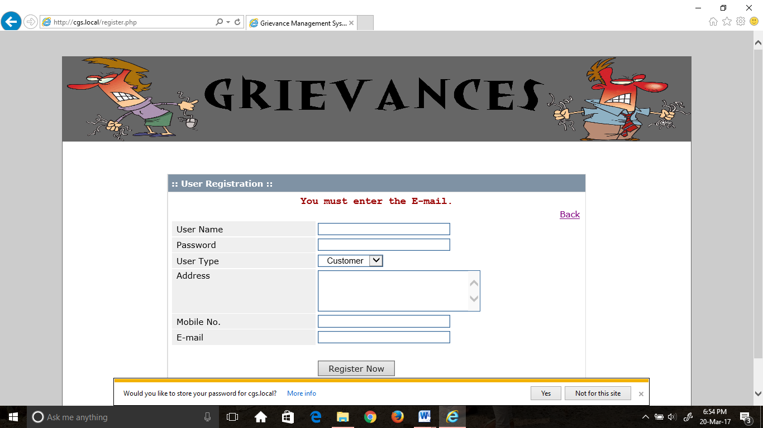

**Screenshot. No: 6.7: Leaving Email Field Empty**

**7. SCREENSHOTS**

**7.1 SCREENS FOR CLIENT MODULE**

**LOGIN page:** Validation is done and will arise an error message are shown, if any. 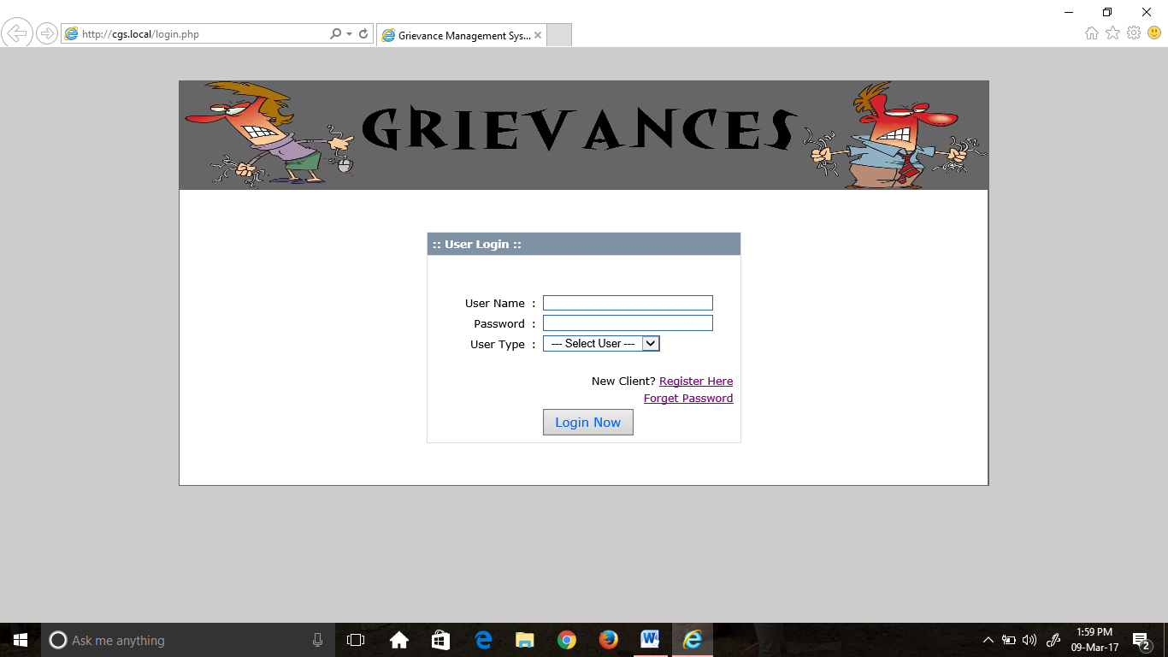

**Screenshot No. 7. 1 Login page**

**REGISTER page:** If the client is a new one, then the client should register first.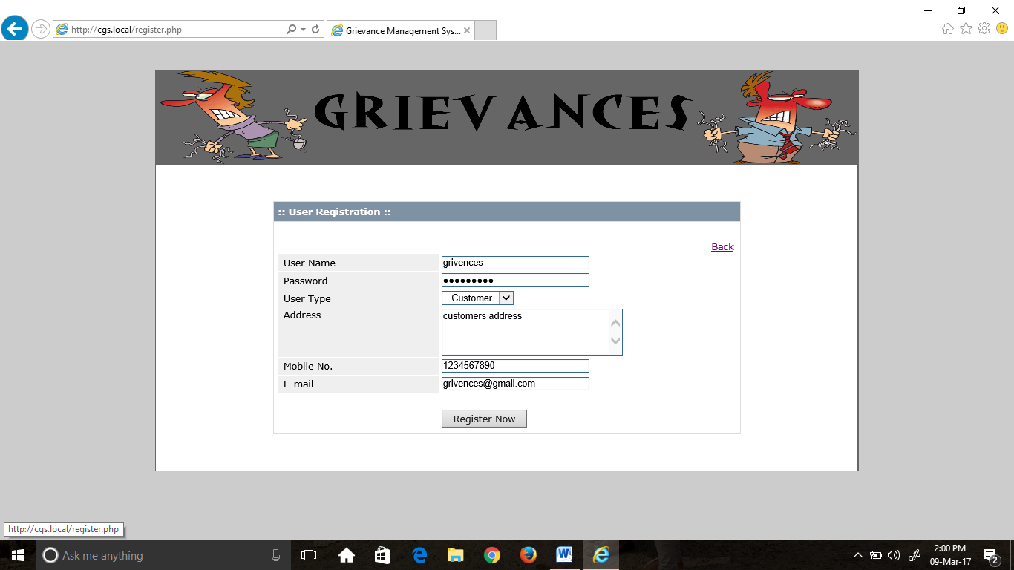

**Screenshot No.7. 2 register page**

**CLIENT login:** In this, the client enters the username and password and selects the user type to login, if any errors during validation, they will be displayed at the top.

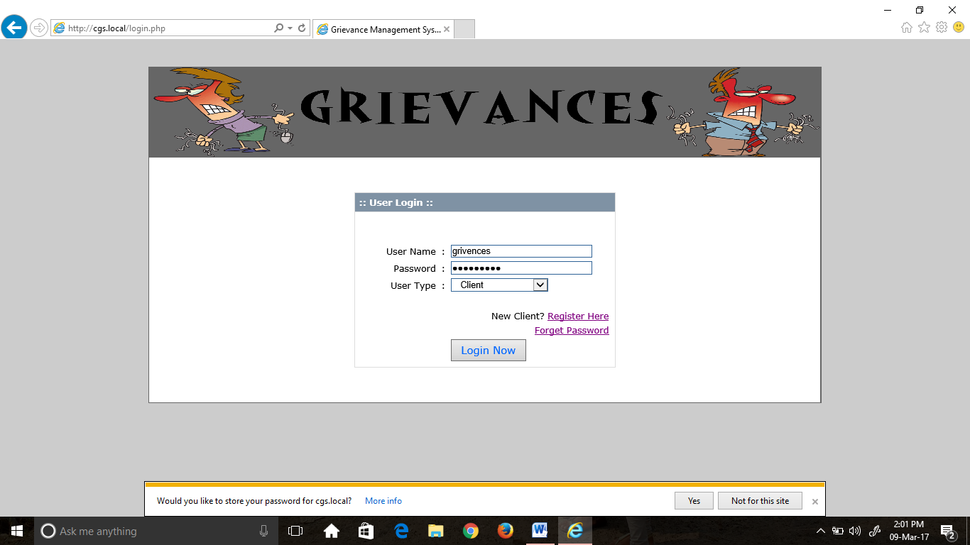

**Screenshot 7.3 client login**

**Client module:** If the user clicks on login, the clients menu along with the home page is displayed.

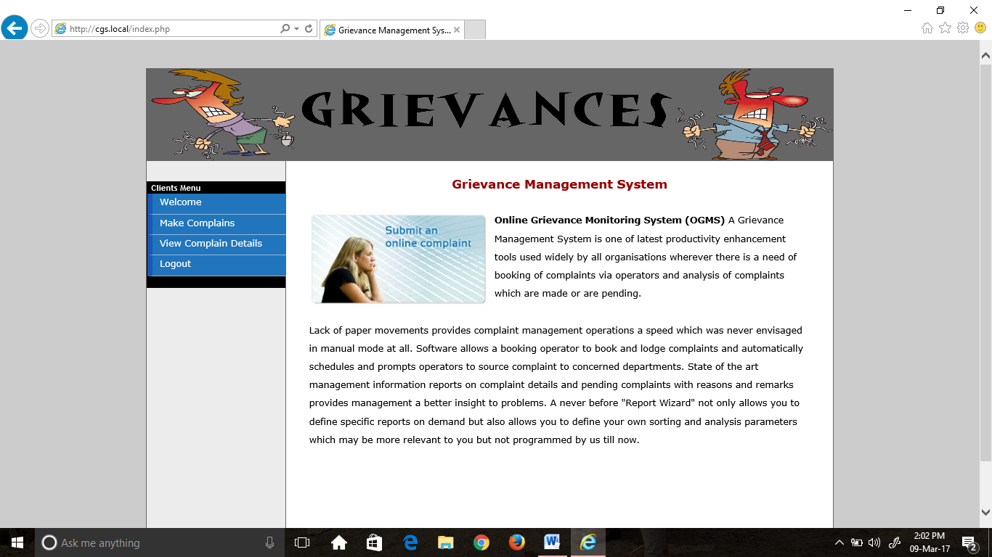 **Screenshot no. 7.4 client home page**

**Make complain:** If the user clicks on make complain the form for giving the complaint details and types of law cases with their attorneys will be displayed.

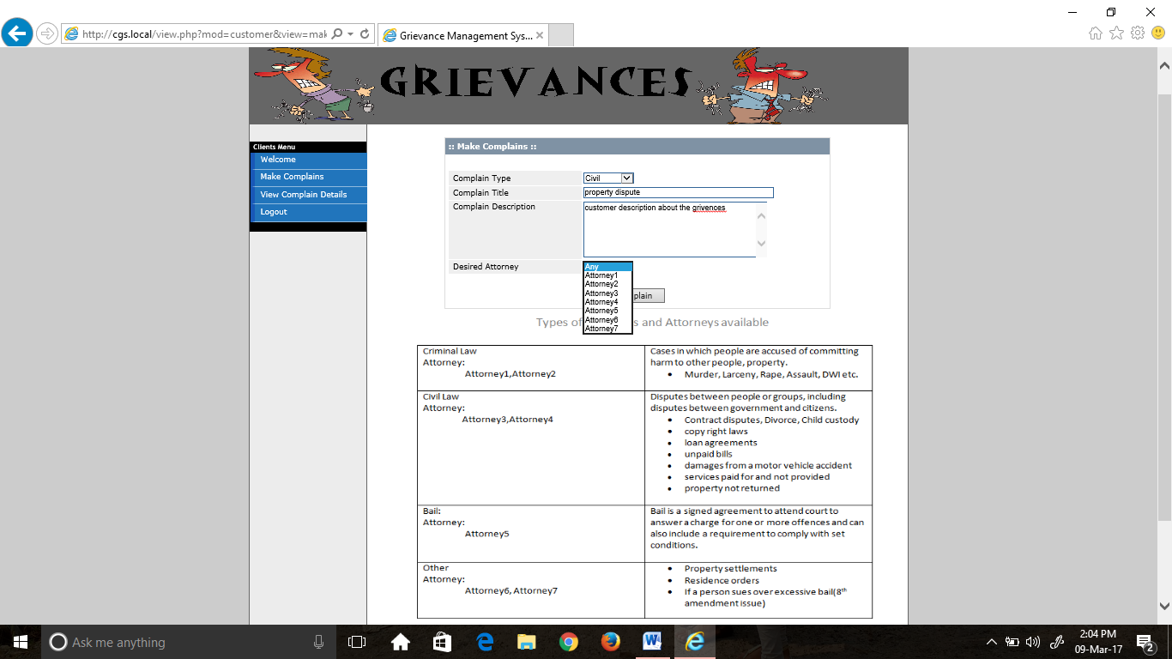

**Screenshot No. 7.5 Make Complain page**

**View Complain Details:** The client can view the complaint details given by him along with the status and comment given by attorney.

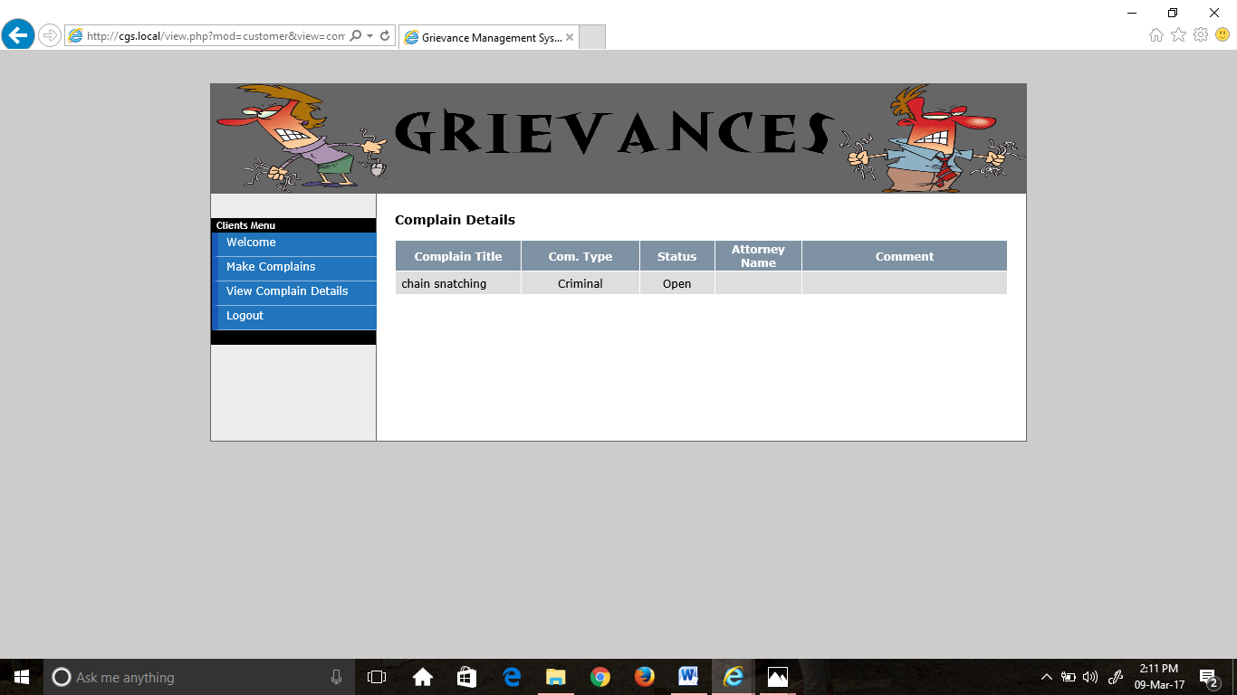 **Screenshot No.7.6 View complain details page**

**7.2 Database creation in PhpMyAdmin**:

* ’complain_db’ database was created.
* Within the database there are three tables named ‘tbl_complains’, ‘tbl_customers’ and ‘tbl_attorneys’ were created.
* ‘tbl_complains’ table holds information about the complaint details given by the client.
* ‘tbl_customers’ table holds the details of clients who are registered.
* ‘tbl_attorneys’ table holds the details of attorneys.

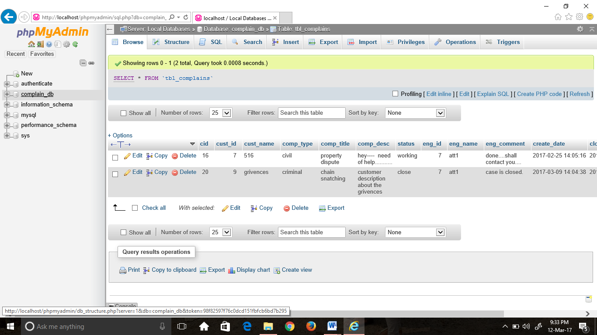

**Screenshot No.7.7 Database- complains table**

**7.3 SCREENS FOR ADMIN MODULE - Admin login**: Admin logs in to the portal using his credentials.

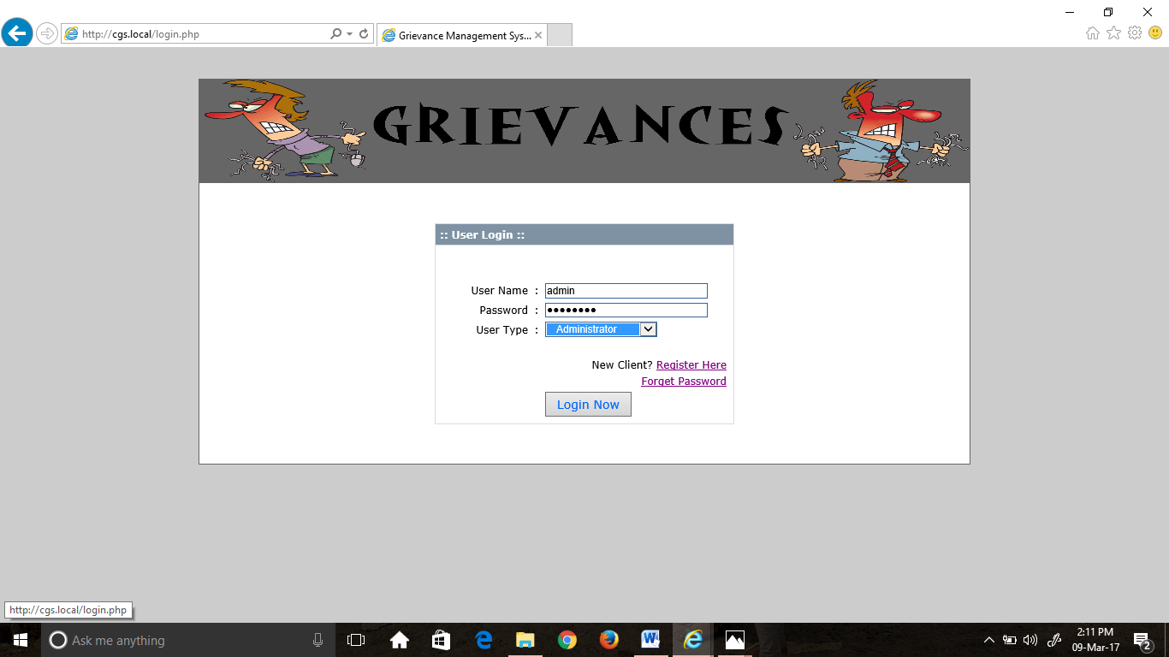

**Screenshot No. 7.8 admin login**

**View complains:** The admin can view the complaints given by the clients and the status.

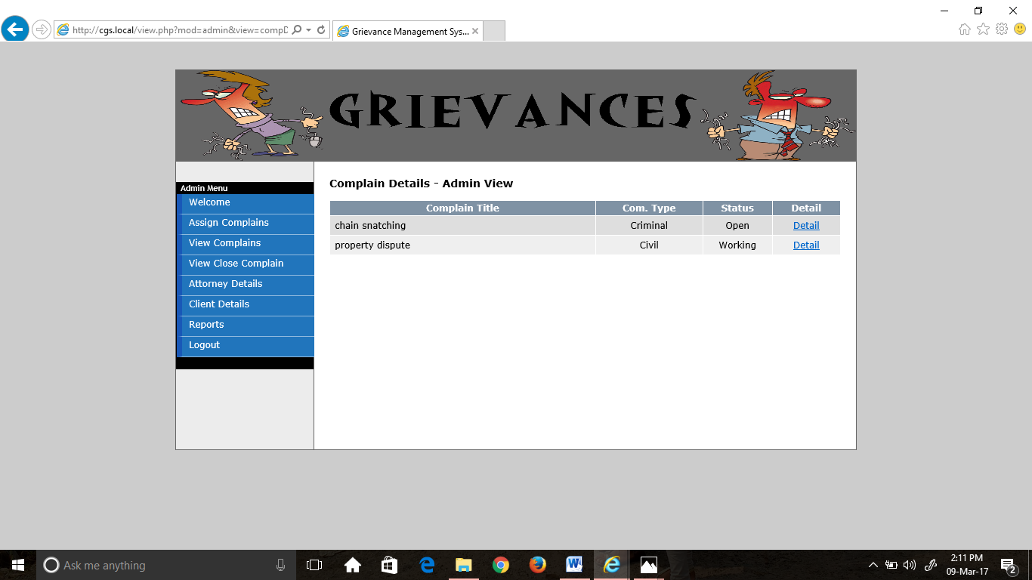 **Screenshot No. 7.9 view complains page**

**Assign Complains:** The admin assigns the complaints to preferred attorney if any.

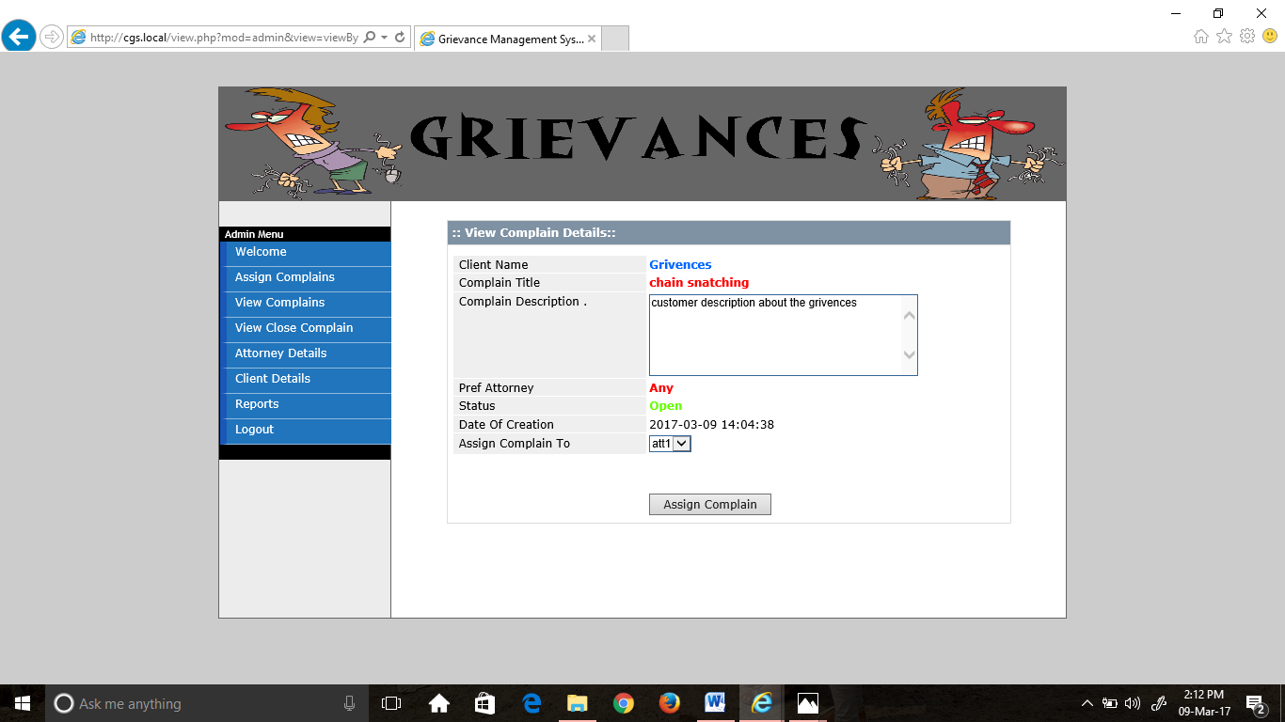

**Screenshot No. 7.10 Assign complains page**

After assigning the complaint to an attorney, the page gets refreshed and displayed as below.

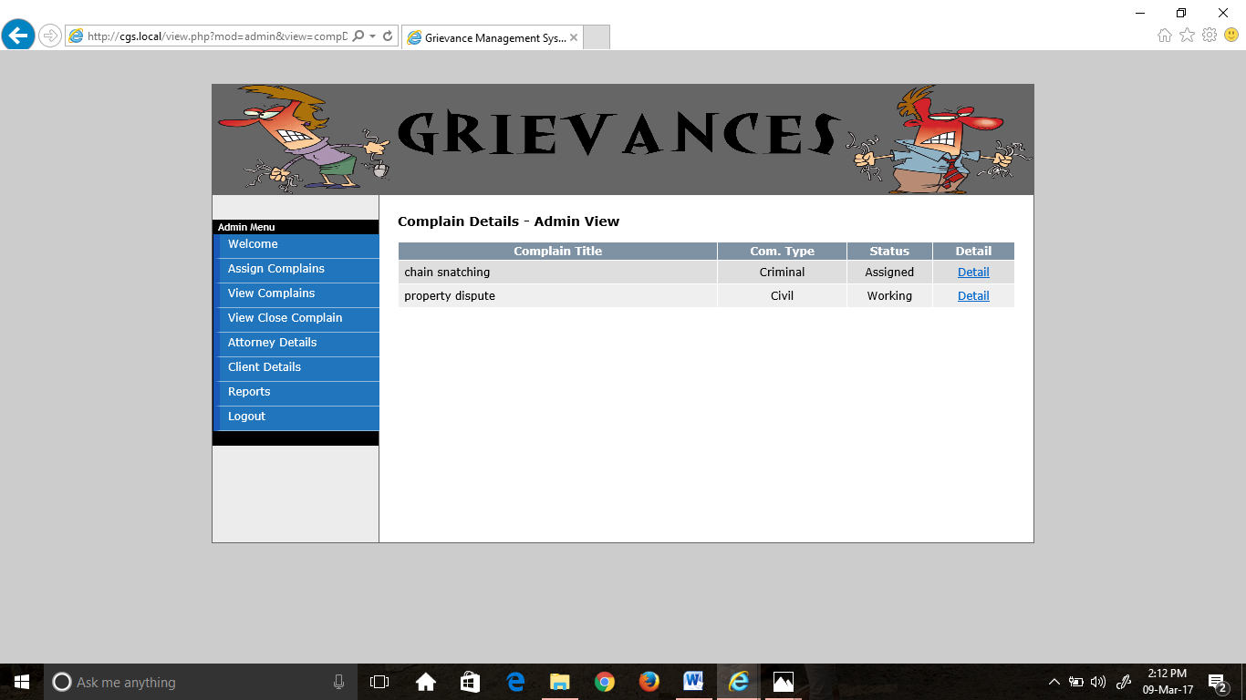

**Screenshot No.7.11 After assignment of complain**

**View Complaint Details:** Latertheadmincanview the complaint details and status as follows.

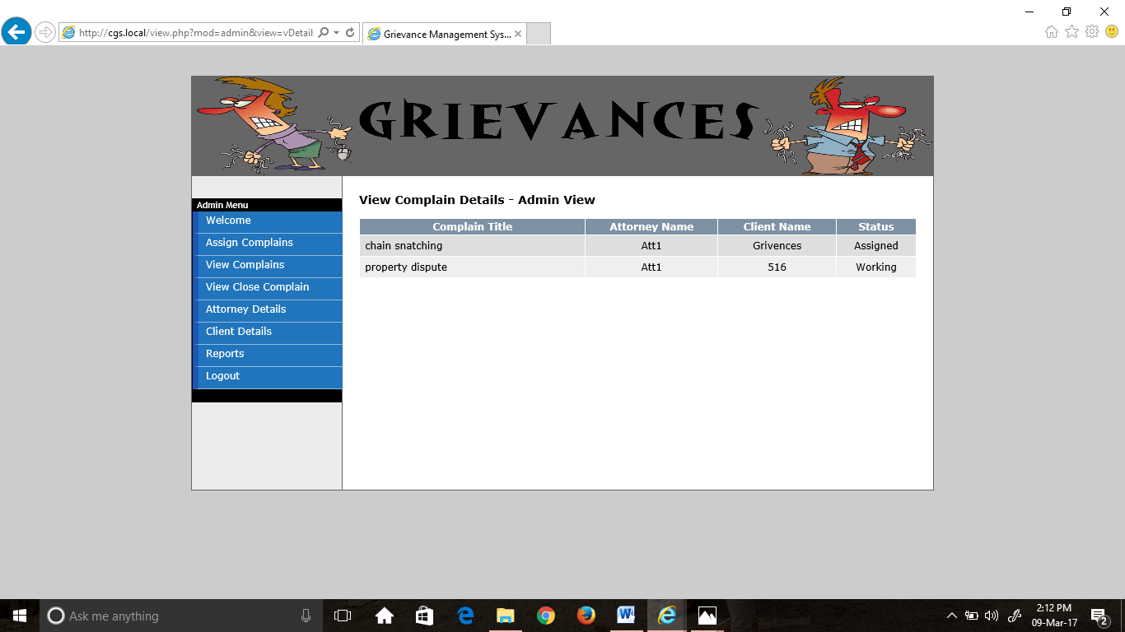

**Screenshot No. 7.12 view complain details**

**Close Complain details:** The details of the closed cases can be viewed here by the admin.

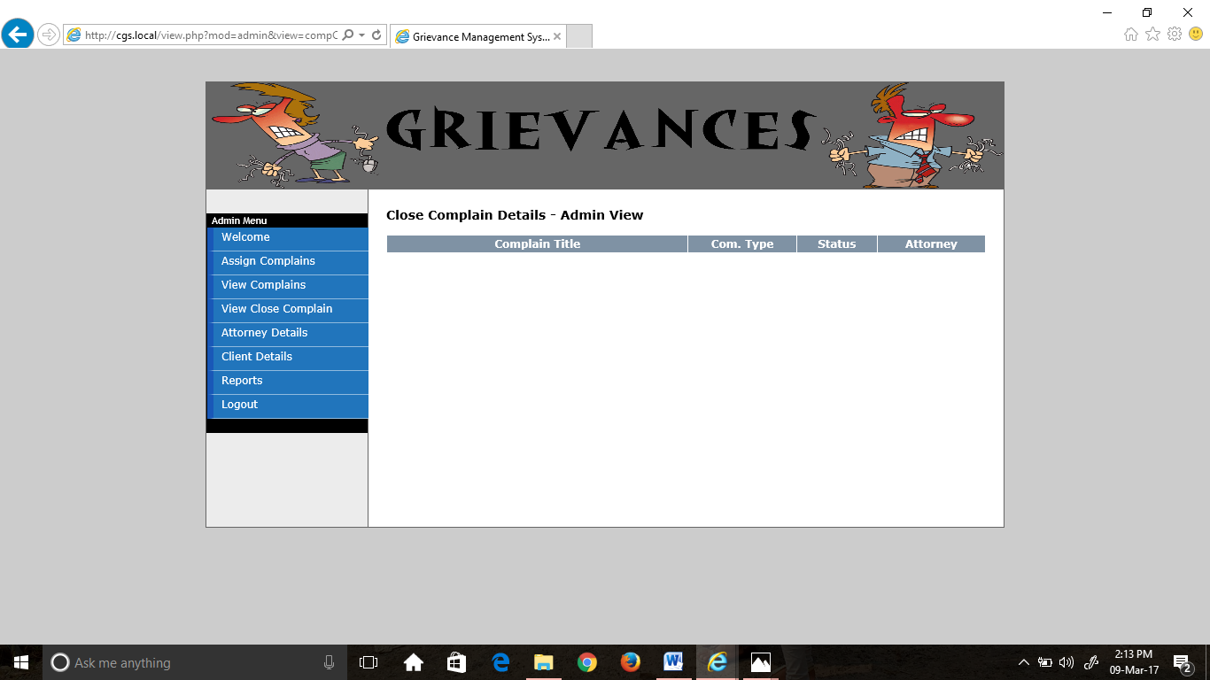 **Screenshot No.7.13 close complain details**

**View/Add attorney:** Admin can view the attorneys available and can add new attorney.

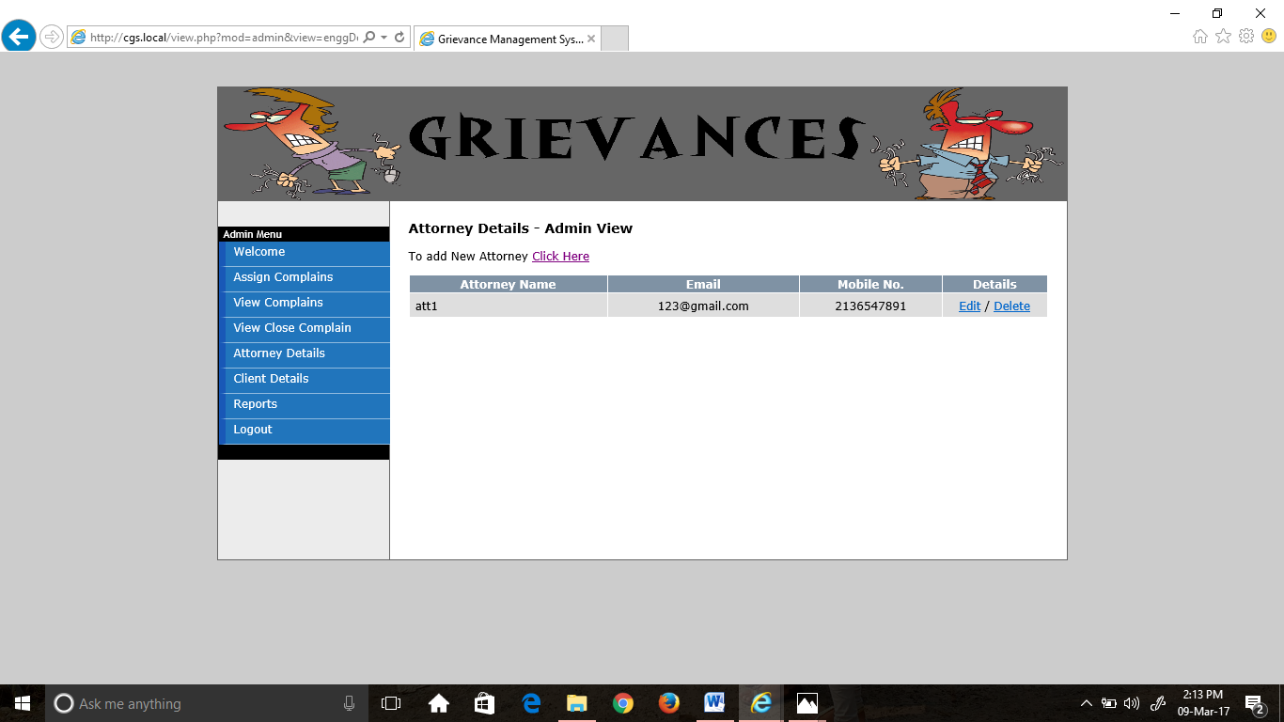

**Screenshot No. 7.14 Attorney details**

**Register Attorney:** To add anew attorney by giving his details.

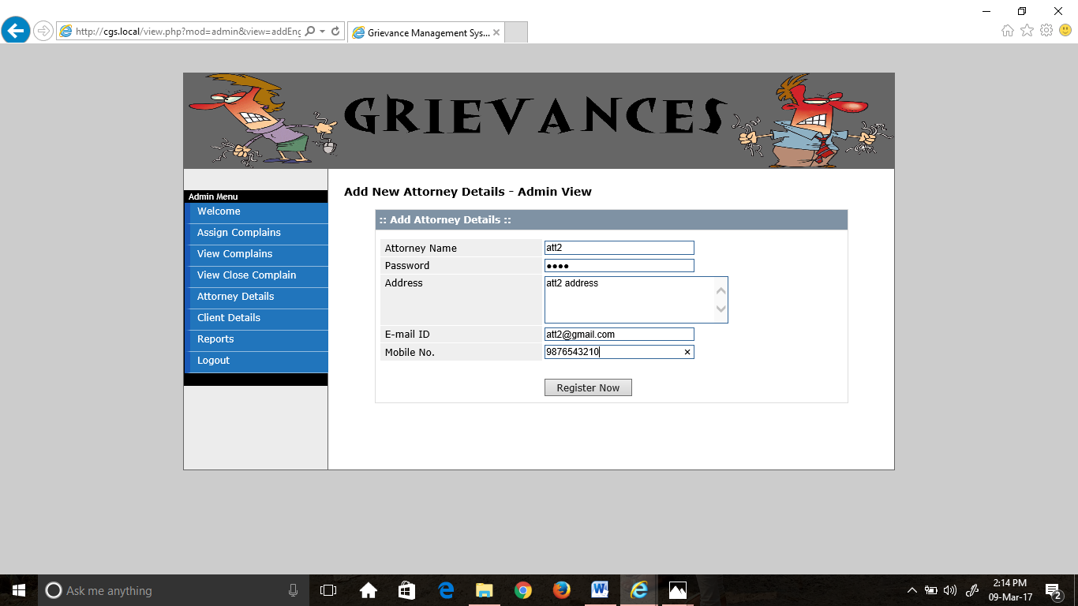 **Screenshot No. 7.15 add new attorney**

**Client Details:** The client details can be viewed here by admin**.**

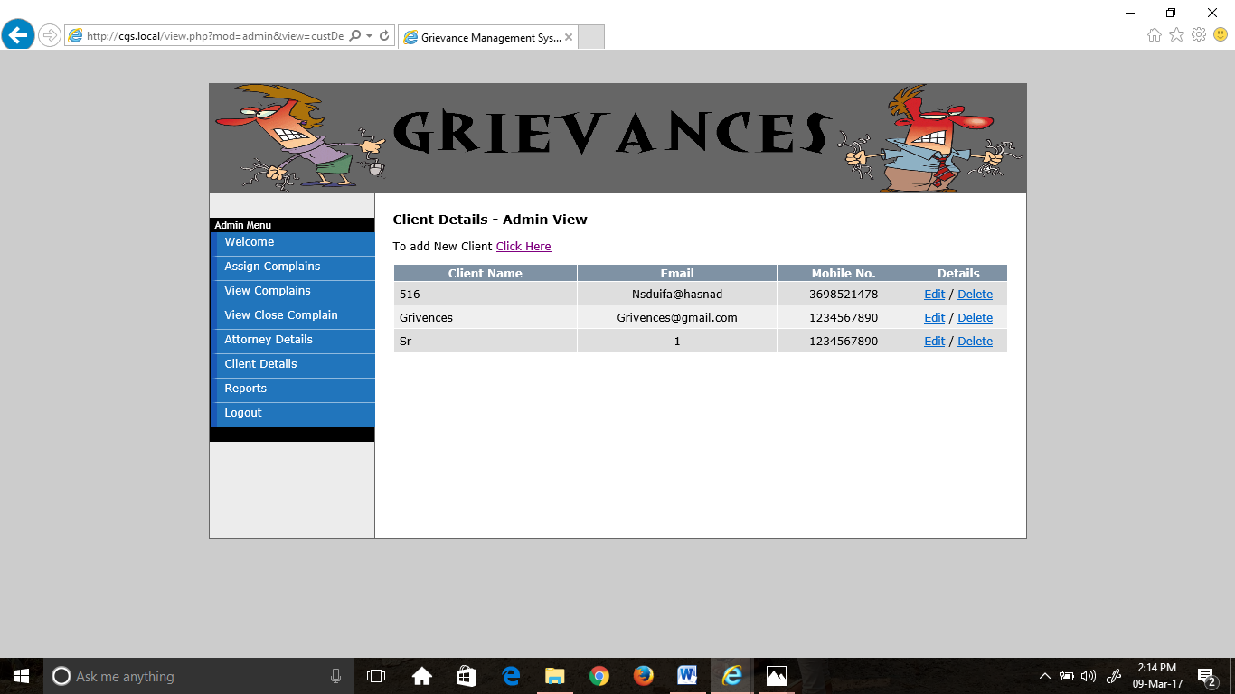

**Screenshot No.7.16 client details**

**Reports:** The complaint status details and user details are displayed in reports tab.

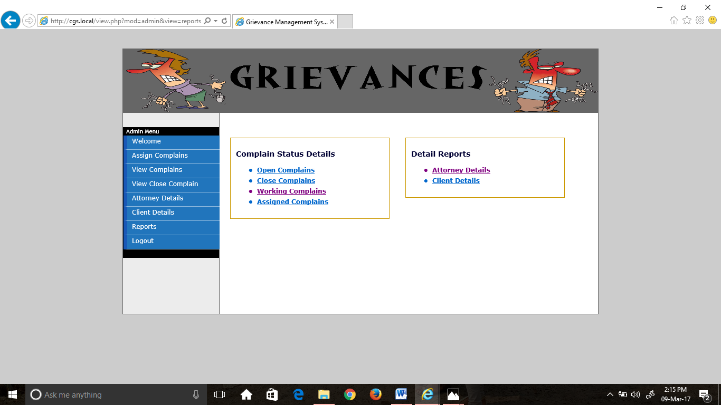

**Screenshot No. 7.17 Reports**

**SCREENS FOR ATTORNEY MODULE- Attorney Login:** Attorney logs into the system with his credentials.

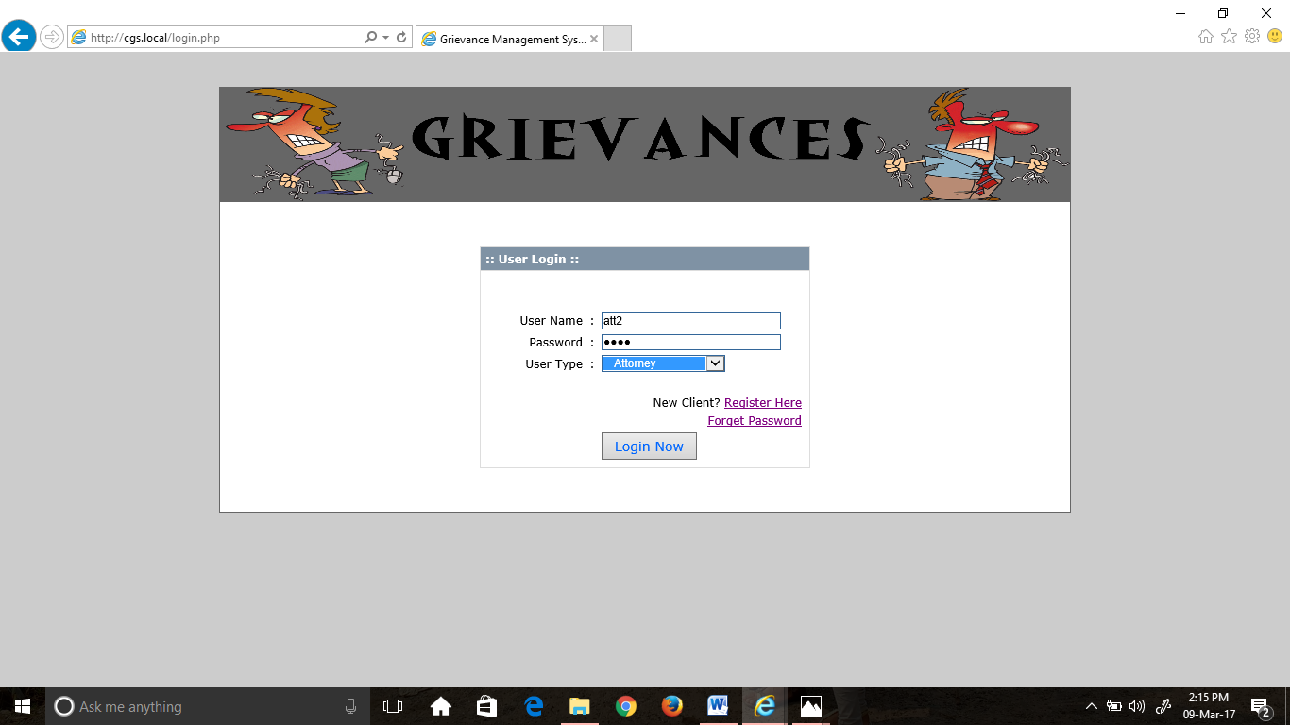

**Screenshot No. 7.18 attorney login**

**View Assign Complains:** Attorney can view the complaints assigned to him.

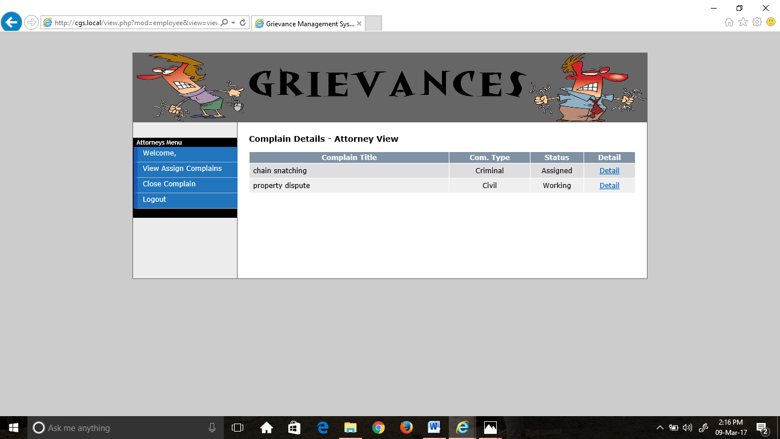 **Screenshot No. 7.19 complain details**

If no complaints are assigned to him, it displays as follows.

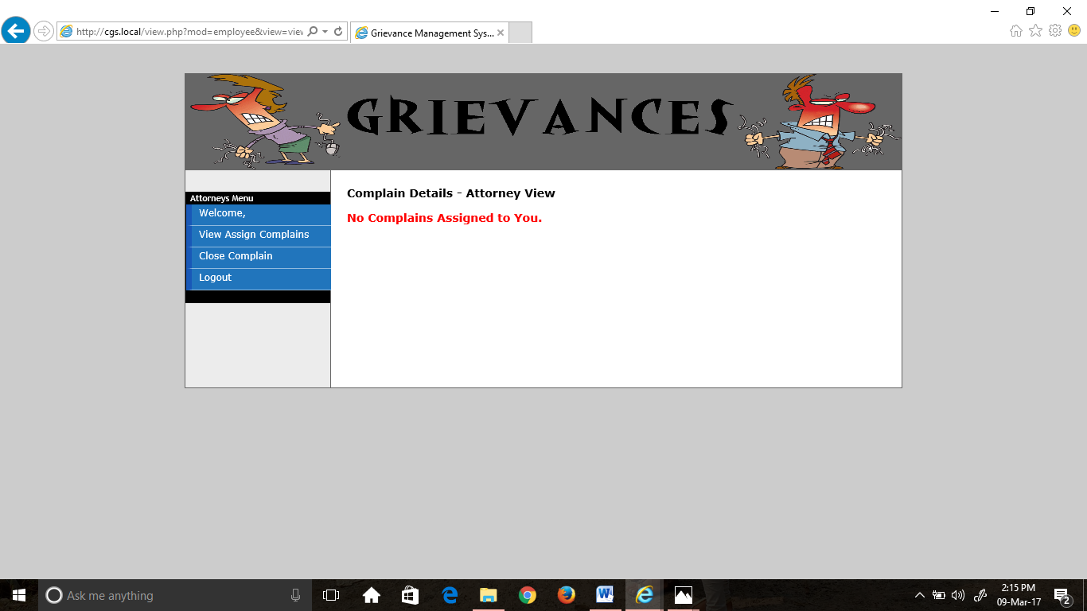

**Screenshot No. 7.20 complaint details**

**View Complain Details:** Attorney can view the details of the specific complaint assigned to him.

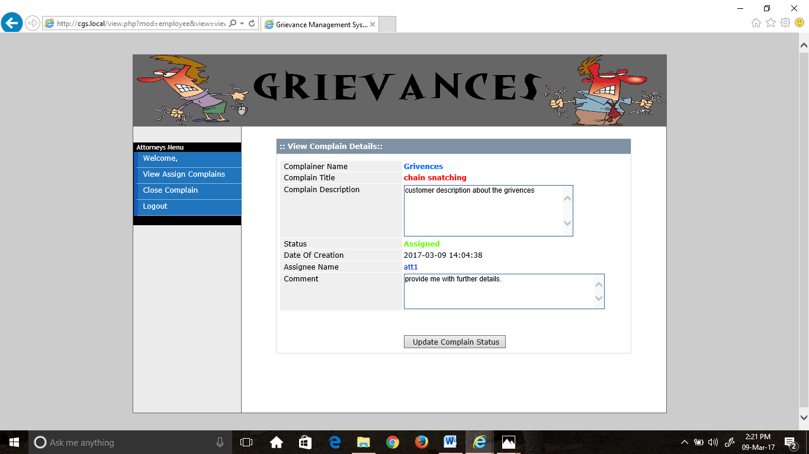

**Screenshot No.7. 21 view complain details**

**Update Status:** The complaint status on updation changes to working from assigned.

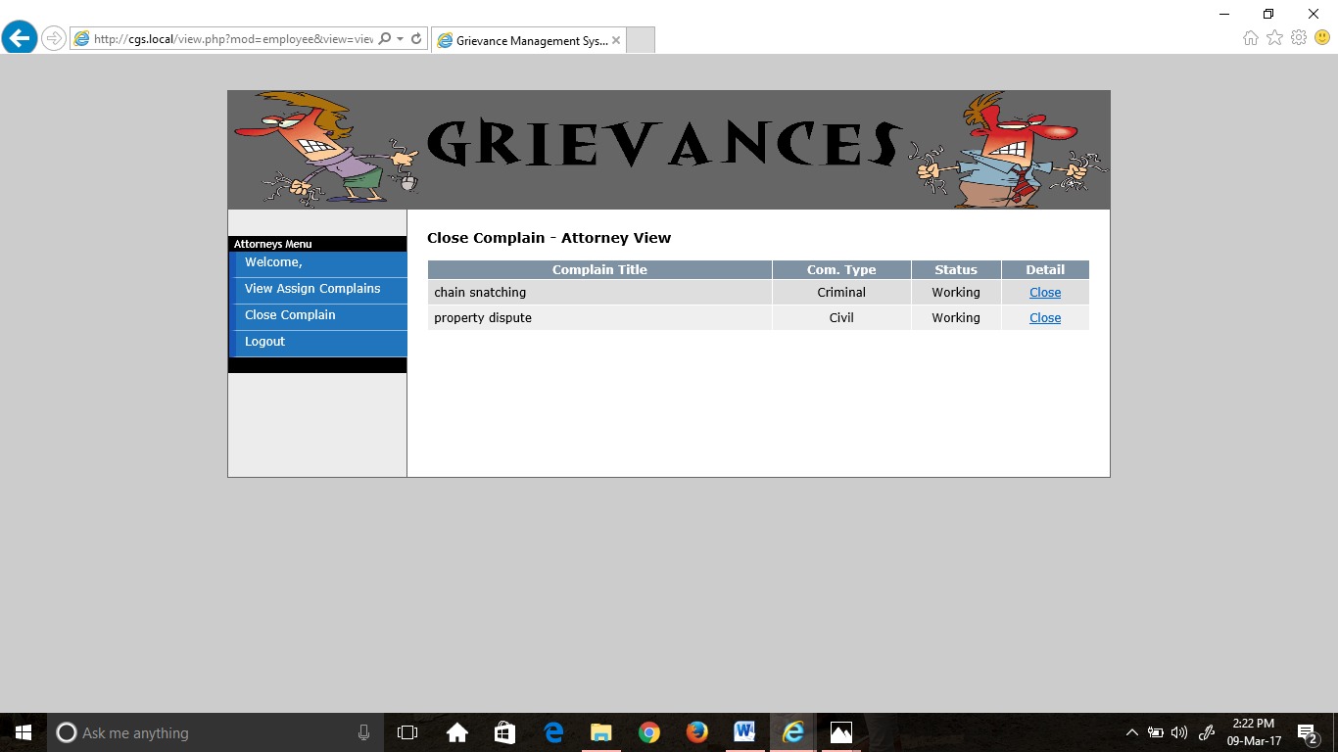

**Screenshot No. 7.22 close complaints**

**Comment in client module:** The comment given by attorney can be viewed from client portal.

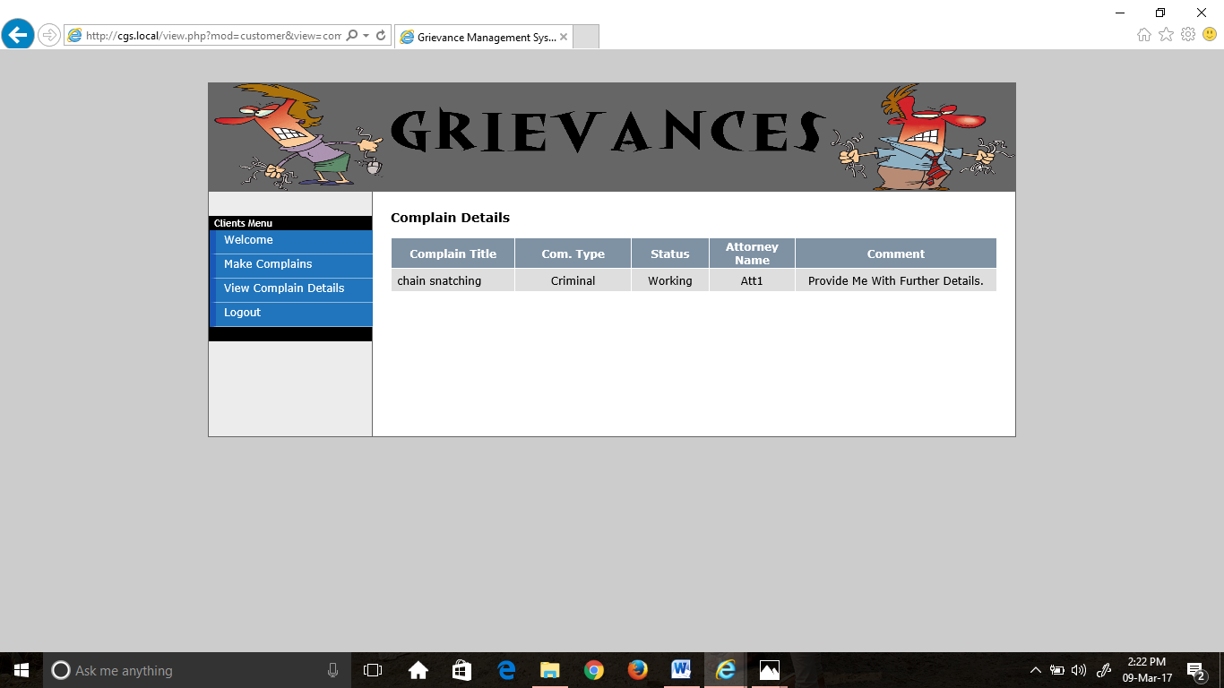

**Screenshot No. 7.23 client - complain details**

**Close Complaint:** Attorney can close the complaint as shown.

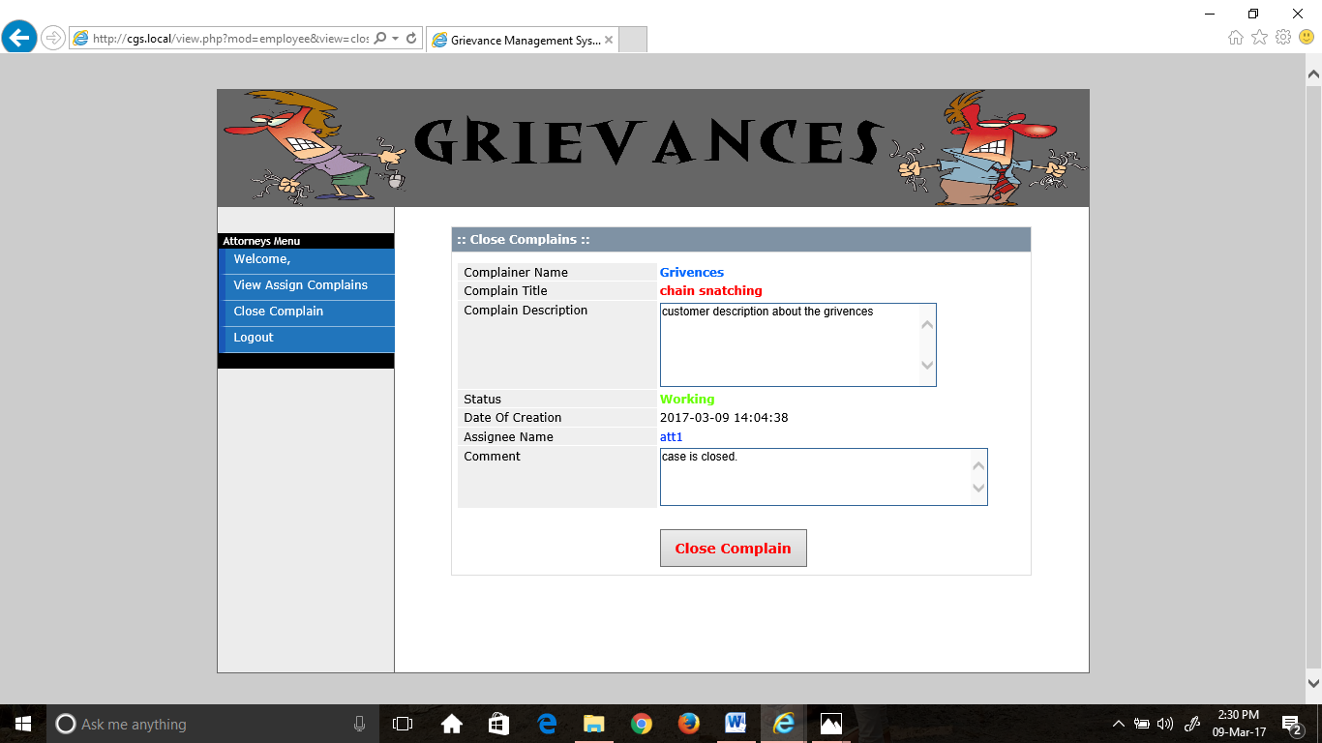

**Screenshot No. 7.24 close complains-attorney**

**Close Complain in admin view:** The complaints with close status can be viewed here.

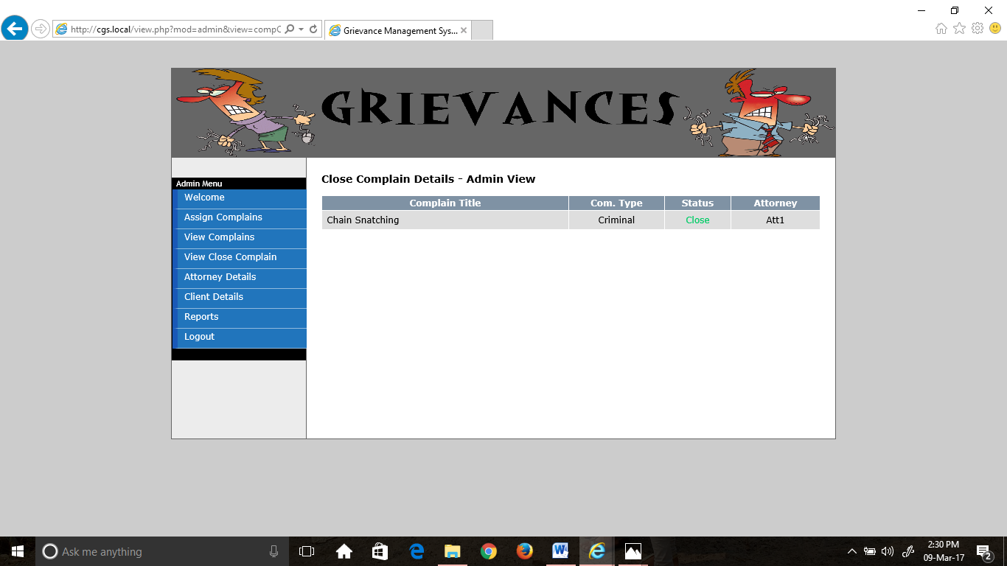 **Screenshot No. 7.25 close complain details - admin**

**8. DOCUMENTATION**

1. First we will install WAMP. [Download WampServer](http://www.wampserver.com/en/download.php) and install it by double clicking on the .exe file. By default it is installed in **C:\wamp.** Leave it as it is. To check if it has been installed correctly open your favorite browser e.g. Internet Explorer, Firefox, Opera, Chrome etc. and type in the address bar**:** <http://localhost>
2. Cretae a virtual host in C:\wamp\bin\apache2.4..\conf\extra\httpd-vhosts.conf and

uncomment this in httpd.conf so that wamp server can read this. Let this be ‘cgs.local’.

1. Now we will create a **MySQL database** for our project. Type a name for your database. We will create the database as root without any password since this website is for testing purposes on my computer only.
2. We can create a database by entering name of database and clicking on create option provided there.
3. We can also select number of tables, number of columns by the means of GUI or also by writing queries in SQL module.
4. In the Database Configuration step select **mysql** as Database, **localhost** as Host Name, **root** as Username, leave the password blank unless you have changed it through PHPMyAdmin, and type the Database Name you've created before through PHPMyAdmin.
5. Now, after we have done with our project php files dump them in the C:\wamp\www directory and start the web browser.
6. Type the url as http://cgs.local/(the last specified folder is our project folder which we are going to execute).
7. Then we will able to run our project by selecting desired options.

**9. CONCLUSION**

The application software has been computed successfully and was also tested successfully by taking “test cases”. It is user friendly, and has required options, which can be utilized by the user to perform the desired operations.

It meets the information requirements specified to a great extent. The system has been designed keeping in view the present and future requirements in mind and made very flexible.

The goals that are achieved by the software are Instant access , Improved productivity, Optimum utilization of resources , Efficient management of records , Simplification of the operations , Less processing time and getting required information, User friendly, Portable and flexible for further enhancement .

**10. SCOPE FOR FUTURE DEVELOPMENTS**

* Modify the project with better approach by providing access to the attorney details.
* Time bound can be placed for the response from the attorney like resending a notification if not responded within few days.
* Admin can contact with both client and attorney through message. Client and attorney can also send message to Admin.

**11. REFERENCES**

1. Practical PHP: The Definitive Guide to Programming PHP by Paul Hudson.1st Edition.
2. The relational model for database management by E.F.Codd, 2nd edition.
3. Modern PHP by Josh Lockhart, O’REILLY publications.
4. PHP and MySQL for dynamic websites : Quick pro guide by Larry Ullman, 4th Edition.
5. HTML and CSS: The complete reference by Thomas Powell, 5th Edition.
6. Database System concepts by Sudarshan and Henry F. Korth, McGraw Hill publications, 4th Edition.
7. <http://wamptutorials.blogspot.in/>
8. <http://www.tutorialspoint.com/php/php_and_mysql.htm>
9. <https://make.wordpress.org/core/handbook/tutorials/installing-local/server/wampserver/>
10. <http://www.hotscripts.com/PHP/>
11. <http://www.w3schools.com/php/php_functions.asp>
12. <http://www.tutorialspoint.com/uml/uml_use_case_diagram.htm>
13. <https://www.smartdraw.com/uml-diagram/>
14. <http://www.tutorialspoint.com/php/php_environment.htm>
15. <https://en.wikibooks.org/wiki/Structured_Query_Language/>